ABOUT THE COLLEGE:
K. Ramakrishnan College of Engineering (KRCE) located in the temple town of Samayapuram in Tiruchirappalli district. The college was established by K. Ramakrishnan Education and charitable trust in the year 2008.The institution is approved by the AICTE and affiliated to Anna University of Technology, Tiruchirapalli, Tamilnadu. The college was founded with noble aim of imparting growth by revamping & sharpening the technical knowledge and abilities of students. The college tops in results, securing the second place among AUTT affiliated colleges continuously. The college maintains high standards in education, provides a wide array of world class academic facilities, employs highly qualified and experienced faculty and creates an ambience conductive to top quality education. The college is committed to providing quality education and hence its mission statement: “Education should end with employment”.
ABOUT THE DEPARTMENT:
The Department of Computer science and engineering was started in 2008. It has well experienced faculty. The faculty team continuously motivates the students to take part in various activities by preaching on current trends, to ensure that students are globally competitive and end product are budding engineers who are scientifically progressive. The vision of our department is to empower every student to succeed in life and to empower every student is inspired and prepared to be a passionate life long learner. The department is also focused to ensure the quality of the programs by managing the resources effectively and efficiently.
CALL FOR PAPERS

Original papers based on the following theoretical and experimental works but not limited to are invited on the following themes.
- Cloud Computing, Grid Computing

- Image Processing

- Nano Computing

- Distributed and Parallel Computing

- Data Mining and Warehousing

- Wireless Communication

- Multimedia Applications

- Intelligent Web Services

- Computational Intelligence

- 3G/4G Networks
IMPORTANT DATES
Submission of Papers : 10th Feb2012.
Date of intimation : 15th Feb2012.
Last date for registration : 20th Feb 2012.
REGISTRATION FEES
PG students : Rs.500/-
Faculty members : Rs.650/-
Delegates from industry : Rs.850/-

ACCOMODATION
Accommodation will be provided for the delegates on prior requisition in the college campus.
REGISTRATION FORM
Second National Conference
On
“INNOVATIONS IN COMPUTING”
NCIC’12
25th February 2012
Name :

Qualification :
Institution/Organization:
Address :

Accommodation Required: YES NO
Phone: E-mail:
Details of DD
Amount: DD No.:
Bank and Branch:

Signature of theApplicant
DECLARATION
Dr./Mr./Ms.
belongs to our institution and will attend the national conference on 25th February 2012.

Place : Signature of the
Date : Authority

ORGANIZING COMMITTEE
Chief Patron Dr. K. Ramakrishnan, B.E,
Chairman, KRGI.

Patron Prof. U. S. Sarvadayaparan,
Director, KRGI.
Dr. D. Srinivasan,
Principal, KRCE.

Convenor Prof. Priya Sethuraman,
HOD/CSE, KRCE.

Co-ordinator Prof.P. S. Tamizharasan
.
Co-Co-ordinators Prof. L. Amudha.
Ms. D. Swathi.

Address for communication:
The Convenor,
National Conference on
“INNOVATIONS IN COMPUTING”
Department of Computer Science and Engineering,
K. Ramakrishnan College of Engineering,
Samayapuram,
Tiruchirappalli-621 112.

SUBMISSION OF PAPERS:
- Registration fee is to be paid by DD drawn favour of, ”The Principal, K.Ramakrishnan College of Engineering” payable at Tiruchirappalli and it should be sent along with the registration form.
- Authors are required to submit the full paper not exceeding 6 pages(A4 size) in IEEE format to the E-mail cse.ncic12@gmail.com
- Only papers submitted before the deadline will be considered for further reviews.
- All selected papers will be included in the conference proceedings.
- Registration is mandatory for every participant.

ABOUT THE CONFERENCE
The proposed conference aims at bringing together various experts, researchers and persons from industry to share their innovative experiences in computing platform. Participation in this conference provides an opportunity to professionals to get knowledge of technology perspectives of recent trends in computing.
The main objective of this conference is to emphasize recent issues and prospective guidelines of computing techniques and technologies for the engineers and researchers.

SECOND NATIONAL CONFERENCE
ON
“INNOVATIONS IN COMPUTING”
(NCIC’12)
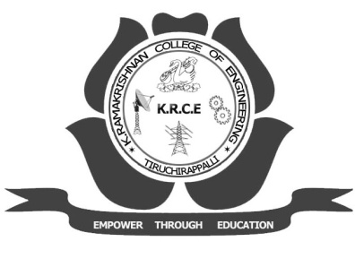
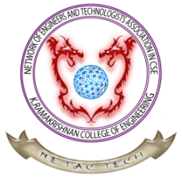
25th FEBRUARY 2012

Organized by

Department of Computer Science &
Engineering,

K. RAMAKRISHNAN COLLEGE OF ENGINEERING,
Samayapuram,
Tiruchirappalli - 621 112.

Contact No.: 9894434024
E-mail: cse.ncic12@gmail.com

