Faculty Name : Mr. A. SELVARAJ Designation : LECTURER
Department : E.E.E. Faculty Code : EE 54
Subject Name : M & I Laboratory Subject Code : 131353
Year : II Semester : III
Degree & Branch : B.E. – E.E.E. Batch : A1

MEASUREMENTS AND INSTRUMENTATION LABORATORY –131353

LIST OF EXPERIMENTS

S.NO | TITLE | PAGE NO
1 | MEASUREMENT OF RESISTANCE USING WHEATSTONE BRIDGE
2 | MEASUREMENT OF RESISTANCE USING KELVIN’S DOUBLE BRIDGE.
3 | MEASUREMENT OF CAPACITANCE USING SCHERING BRIDGE.
4 | MEASUREMENT OF INDUCTANCE USING MAXWELLS BRIDGE.
5 | CALIBRATION OF 1∅ ENERGYMETER.
6 | MEASUREMENT OF 3 PHASE POWER AND POWER FACTOR
7 | INSTRUMENTATION AMPLIFIER.
8 | STUDY OF DISPLACEMENT TRANSDUCER - LVDT
9 | STUDY OF PRESSURE TRANSDUCER
10 | A/D CONVERTER
11 | D/A CONVERTER
12 | STUDY OF TRANSIENTS
13 | CALIBRATION OF CURRENT TRANSFORMER
14 | MEASUREMENT OF IRON LOSS (MAXWELL BRIDGE)

EXPT. NO. 1 MEASUREMENT OF RESISTANCE USING
WHEATSTONE BRIDGE

AIM:
To measure the given medium resistance using Wheatstone bridge.

OBJECTIVE:
To study the working of bridge under balanced and unbalanced condition and to study the sensitivity of bridge.
APPARATUS REQUIRED:

SL.NO | NAME OF THE APPRATUS | RANGE | TYPE | QTY
1  2  3  4 | Wheat stone Bridge kit  Unknown resistance  Multimeter  Connecting Wires.

CIRCUIT DIAGRAM:
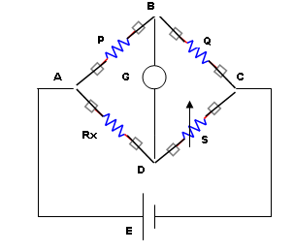

THEORY:

FORMULAE USED:
Unknown Resistance, R_{x} = (P/Q) S (Ω)
Where P, Q = Ratio Arms.
S = Variable resistance,
R_{x} = Unknown resistance.

PROCEDURE:
1. The resistance to be measured is connected between XX points in the bridge kit.
2. The P/Q ratio (multiplier) is initially kept at position ‘1’ and the deflection of the
galvanometer is observed by pressing both the battery and the galvanometer keys.
3. The S arm (X 1000Ω) is adjusted and two positions are identified for which the
deflection of the galvanometer is on either side of the null point and kept at the lowest
value of S. Then the x100Ω, x10Ω, x1Ω knobs of S are adjusted to get null deflection.
If necessary the sensitivity knob may be adjusted to get appreciable deflection. [If not
possible P/Q ratio is kept at any other suitable value ie, any one of ratios provided.]
4. The value of unknown resistance is read. (S value)
5. Steps 3 and 4 are repeated for some other P/Q ratio. The mean value is taken.
6. The experiment is repeated with other samples provided.

NOTE: The above experiment may be used for measuring resistance of the samples less than 1Ω to greater than 10kΩ with lesser sensitivity.

TABULAR COLUMN:

S.NO | SAMPLE | P/Q RATIO  (MULTIPLIER) | S VALUE  (Ω) | UNKNOWN  RESISTANCE  R_{X} (Ω)

CALCULATION:

RESULT:

EXPT. NO. 2 MEASUREMENT OF RESISTANCE USING KELVIN’S DOUBLE BRIDGE

AIM:
To measure the given low resistance using Kelvin’s double bridge method.

OBJECTIVE:
To study the working of bridge under balanced and unbalanced condition and to study the sensitivity of bridge.
APPARATUS REQUIRED:

SL.NO | NAME OF THE APPRATUS | RANGE | TYPE | QTY
1  2  3  4 | Kelvin Double bridge kit Unknown resistance  Multimeter  Connecting Wires

CIRCUIT DIAGRAM:

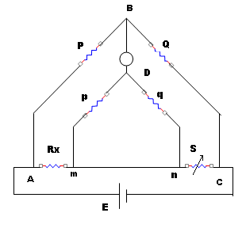

THEORY:

FORMULA USED:

R_{x} = (P/Q) S ohms
Where
P, Q → first set of ratio arms.
p, q → Second set of ratio arms.
S → Standard resistance,
R_{x} → unknown resistance.

PROCEDURE:

1. The resistance to be measured is connected such that the leads from +C and + P are
connected to one end and those from –C and –P are connected to the other end in the
kit.
2. The P/Q ratio (multiplier) is initially kept at position ‘1’ and the deflection of the
galvanometer is observed by pressing the galvanometer key.
3. The ‘S’ arm (main dial) is adjusted and two positions are identified for which the
deflection of the galvanometer is on either side of the null point. [If not some other P/Q
ratio is to be tried].
4. The lowest of the two position indicates the coarse value of the unknown resistance
and the null point is obtained by adjusting the Vernier scale, with the galvanometer
sensitivity knob at the maximum position.
5. The value of unknown resistance is read. [‘S’ Value]
6. Steps 3, 4, 5 are repeated for some other P/Q ratio for the unknown resistance. The
mean value is taken.
7. The above procedure is repeated with another sample.

TABULAR COLUMN:

S.NO | SAMPLE | P/Q RATIO  (Multiplier) | S VALUE  COARSE(Ω) FINE ( Ω) | UNKNOWN RESISTANCE  R_{x} (Ω)
.
CALCULATION:

RESULT:

EXPT. NO. 3 MEASUREMENT OF CAPACITANCE USING
SCHERING BRIDGE

AIM:
To measure the unknown capacitance using Schering bridge.

OBJECTIVE:
To measure the unknown capacitance and to study about dissipation factor.
APPARATUS REQUIRED:

SL.NO | NAME OF THE APPRATUS | RANGE | TYPE | QTY
1  2  3  4  5 | Schering Bridge kit Unknown capacitance  Multimeter  Connecting Wires  CRO

CIRCUIT DIAGRAM:

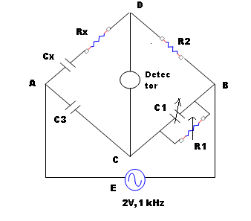

THEORY:

FORMULA USED:

1. Unknown capacitance, C_{x} = (R₁/R₂) C₃,
Where C₃ is known capacitance in µF
R₂ is Non-Inductive Variable Resistor
2. Dissipation factor, D = ω R₁ C₁ = ω R_{x} C_{x}

PROCEDURE:

- The oscillator AB and the bridge AB terminals are connected.
- From the CD terminals of the bridge, the detector (loudspeaker) is connected through an imbalance amplifier.
- Connections of the bridge arm are made as per the circuit diagram.
- The value of R₂ is selected arbitrarily (say1K) and R₁ is kept at maximum position.
- The kit is switched on and R1 is decreased until the null point is observed as a dip in the sound from the loudspeaker.
- The capacitor C₁ can be varied for fine balance adjustment.
- When the balance condition is reached, the trainer kit is switched OFF and the value R₁ is measured using a multimeter.
- The value of unknown capacitance and dissipation factor is calculated.
- The experiment is repeated for various samples provided.

TABULAR COLUMN:

S.NO | SAMPLE | R₂ (Ω) | R₁ (Ω) | UNKNOWN CAPACITANCE C_{x} (µF)

CALCULATION:

RESULT:

EXPT. NO. 4 MEASUREMENT OF INDUCTANCE USING
MAXWELLS BRIDGE

AIM:
To find the unknown inductance and Q factor of a given coil.

OBJECTIVE:
To find the unknown inductance of the given coil using bridge circuit and to study that Maxwell inductance- capacitance bridge is suitable for the measurement of low Q coils.

APPARATUS REQUIRED:

SL.NO | NAME OF THE APPRATUS | RANGE | TYPE | QTY
1  2  3  4  5  6 | Maxwell’s inductance Capacitance Bridge kit  Unknown Inductance  Multimeter  Connecting Wires  CRO  Bridge oscillator | 1 kHZ

CIRCUIT DIAGRAM:

R3
L1
R1
D
C4

R2
R4

THEORY:

FORMULAE USED:

1. Unknown resistance, R₁=R₂R₃ / R₄ (Ω)
2. Unknown Inductance, L₁=R₂R₃C₄ Henry
Thus we have two variables R4 and C4 which appears in one of the two balance equation and hence the two equations are independent, and balance is obtained by varying R4 and C4 alternately.
3. Quality factor, Q = ωL₁ / R₁ = ωC₄R₄

PROCEDURE:
- The inductance to be measured is connected between L1 terminal of the kit.
- The bridge oscillator is set for 10Vpp, 1 kHz and connected to the OSC terminal of the kit.
- The detector CRO or headphone is connected to the headphone terminal of the kit.
- The R4 and C4 are adjusted from the highest range (among the 3 range knobs) to obtain the null point in the detector. [ Null point – For increase in R4 and C4 values the point at which the amplitude reduces to a minimum and then increases is null point).
- At the null point the values of R4 and C4 are noted.
- The value of unknown resistance, inductance and quality factor are calculated.
- The experiment is repeated with other samples provided.

TABULAR COLUMN:

S.NO | SAMPLE | R₄(Ω) | C₄ (F) | UNKNOWN INDUCTANCE  (H)

CALCULATION:

RESULT:

EXPT. NO. 5 CALIBRATION OF SINGLE PHASE ENERGYMETER

AIM:

To calibrate the given single phase energy meter at unity and other power factors

OBJECTIVE:
- To study the working of energy meter.
- To accurately calibrate the meter at unity and other power factor.
- To study the % of error for the given energy meter.
APPARATUS REQUIRED:

SL.NO | NAME OF THE APPRATUS | RANGE | TYPE | QTY
1  2  3  4  5  6 | Energy meter  Wattmeter  Ammeter  Voltmeter  Stop watch  Connecting Wires

CIRCUIT DIAGRAM:

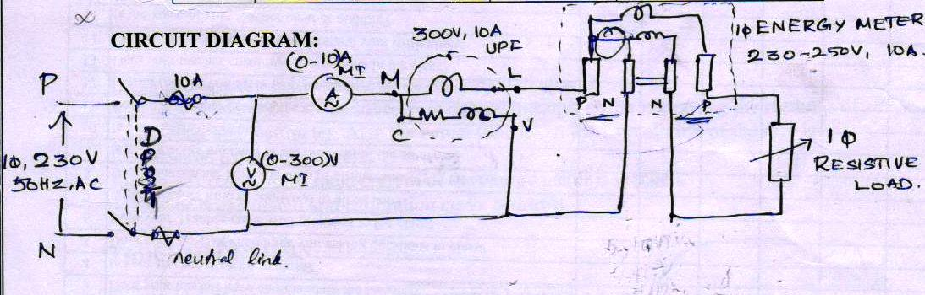

NAME PLATE DETAILS:
RATED CURRENT
RATED VOLTAGE
FREQUENCY
REVOLUTIONS/KWH

THEORY:

FORMULAE USED:
Let x revolution / kwh be the rating.
Now x revolution = 1 kwh
= 1* 3600*1000 watt-sec.
Constant k of energymeter = 3600 * 10³/ x watt-sec
For each load, indicated power Wi is given as Wi = k/t watts
Where
K= energy meter constant (watt-sec)
t = time for 1 revolution(sec)
% error = Wi – Wa / Wi * 100
Where Wi is indicated power in watts
Wa is actual power shown by wattmeter in watts

% error can be zero +ve or –ve.

PROCEDURE:

1. Connections are given as shown in the circuit diagram.
2. Supply is switched ON and load is increased in steps, each time noting the readings of
ammeter and wattmeter. Also the actual time taken for 1 revolution of the disc is
measured using stop watch.
3. Step 2 is repeated till rated current of the energy meter is reached.
4. % error is calculated and calibration curve is drawn.

TABULAR COLUMN:

S.NO | LOAD CURRENT  I (Amps) | WATTMETER  READING, Wa (W) | INDICATED  POWER, Wi (W) | Time taken , t (secs) | % ERROR

CALCULATION:

MODEL GRAPH:

+Ve
% Error
0
Wi

-Ve

NOTE:
From the calibration curve it is possible to predict the error in recording the energy. So the correction can be applied to the energy meter reading so that correct energy reading can be obtained and used.

RESULT:

EXPT. NO. 6 MEASUREMENT OF THREE PHASE POWER
AND POWER FACTOR

AIM
To conduct a suitable experiment on a 3-phase load connected in star or delta to measure the three phase power and power factor using 2 wattmeter method.

OBJECTIVES
- To study the working of wattmeter
- To accurately measure the 3 phase power
- To accurately measure the power factor
- To study the concept of star connected load and delta connected load
APPARATUS REQUIRED:

S.NO | NAME OF THE APPRATUS | RANGE | TYPE QTY
1  2  3  4  5 | Ammeter  Voltmeter  Wattmeter  Connecting Wires  3 phase inductive load
CIRCUIT DIAGRAM:
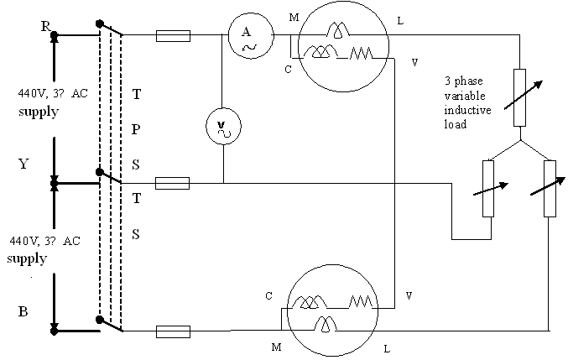

THEORY:

FORMULA USED:

- Total power, P = W1+W2 (W)
- φ= Tan-1 √3 [(W1-W2) /(W1+W2)]
3. P.F = Cosφ

PROCEDURE:

- Connection are made as per the circuit diagram, keeping the inductive load in the
initial position.
- Supply switch is closed and reading of ammeter and wattmeter are noted .If one of the wattmeter reads negative, then its potential coils (C and V) are interchanged and
reading is taken as negative.
3. The above procedure is repeated for different values of inductive coil. Care should be
taken that current should not exceed 10A during the experiment.

TABULAR COLUMN:

S.NO | I | W1 | W2 | POWER, P | P.F  Cosφ
 | (Amps) | (Watts) | (Watts) | (Watts)

CALCULATION:

RESULT:

EXPT. NO. 7 INSTRUMENTATION AMPLIFIER.

AIM:
To study the working of instrumentation amplifier.

OBJECTIVE:

- To study the characteristic of operational amplifier.
- To study the use of operational amplifier as instrumentation amplifier.
APPARATUS REQUIRED:

S.NO | NAME OF THE APPRATUS | RANGE | TYPE QTY
1  2  3  4 | Instrumentation Amplifier Kit  Dual RPS  Multi meter  Connecting Wires

PIN DIAGRAM:
PIN DIAGRAM OF IC741

CIRCUIT DIAGRAM:
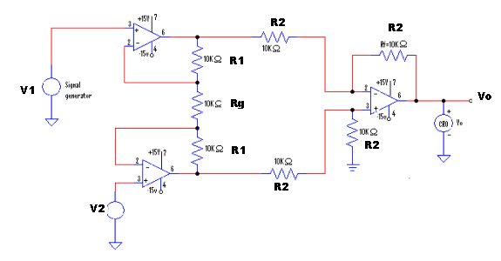
R1 = R2 = R

THEORY:

FORMULAE USED:
- Vo= (V2 – V1) (1 + 2R / Rg)

PROCEDURE:

- Connect a dual RPS to the input terminals V1 and V2 of either channel 1 or channel 2 of instrumentation amplifier module.
- Adjust the RPS for different voltages for V1 and V2 (not more than 10 V).
- Measure the output voltage using a multi meter for every set of V1 and V2.

TABULAR COLUMN:

V₁ (v) | V₂ (v) | V_{out} (v)

RESULT:
EXPT. NO. 8 STUDY OF DISPLACEMENT TRANSDUCER - LVDT

AIM
To study the operation of LVDT- Linear Variable Differential Transformer

OBJECTIVE:
- To study the basic principle of LVDT.

- Study of signal conditioning circuit.

3. Study of LVDT as transducer.

APPARATUS REQUIRED:

S.NO | NAME OF THE APPRATUS | RANGE | TYPE QTY
1  2  3  4 | LVDT kit  Multimeter  Connecting Wires

THEORY:

CIRCUIT DIAGRAM:

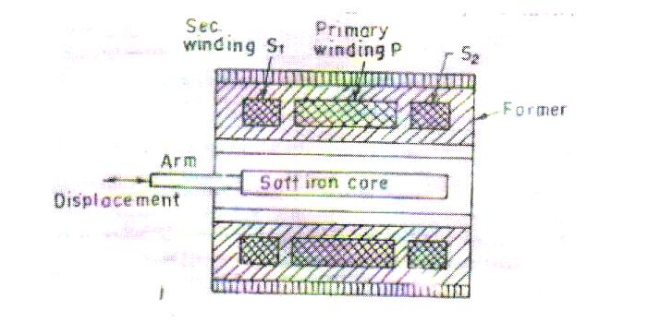
Fig.1
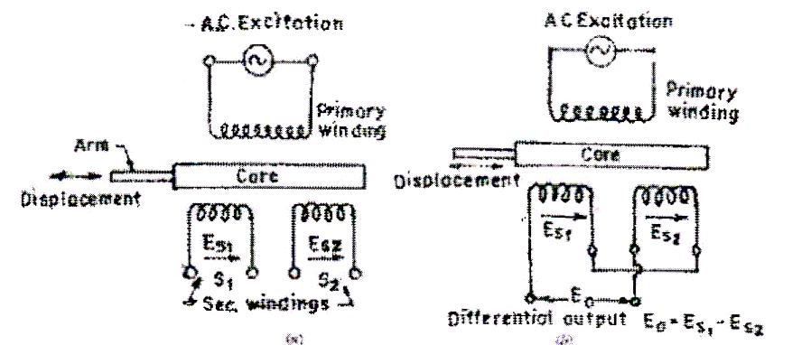
Fig.2

PATCHING DIAGRAM:

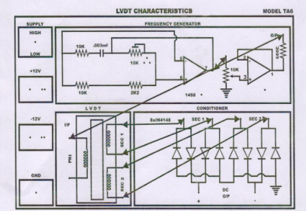

PROCEDURE:
- The trainer is switched and power supply is checked for +12V and -12Vwith the help of multi meter.
- The trainer is switched off and connections are made as per the patching diagram.
- The LVDT is connected in the kit through connector provided in the circuit.
- The displacement of LVDT is kept at one end by using screw guage.
- The trainer is switched on and the output DC voltage is measured using multimeter by connecting it across DC output + and – respectively.
- The displacement is varied with the help of screw gauge and the corresponding output voltages are noted down.
- The screw gauge is adjusted for maximum displacement and then stopped.
- A graph between displacement and output voltage is drawn.

TABULAR COLUMN:

S.NO | DISPLACEMENT ON  MICRO-METER (mm) | MULTIMETER READING (Volts)

MODEL GRAPH:
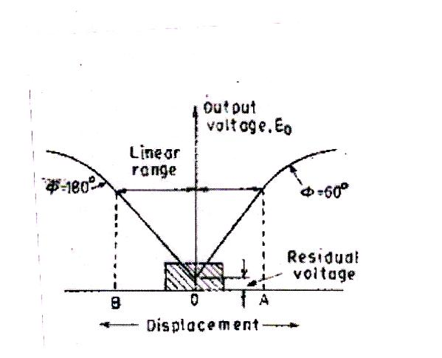
RESULT:

EXPT. NO 9 STUDY OF PRESSURE TRANSDUCER

AIM
To study the operation of a pressure transducer – Strain gauge.

OBJECTIVES
- To study the basic principle of Strain gauge.

- Study of Strain gauge as transducer.

APPARATUS REQUIRED:
S.NO | NAME OF THE APPARATUS | RANGE | TYPE | QUANTITY
1  2 | Pressure measurement module  Multimeter

THEORY:

FORMULAE USED:

% Error = [(Gauge pressure – displayed pressure) / displayed pressure] * 100

PROCEDURE:

- Install the pressure cell setup and interface the 9 pin D connector with the pressure measurement module. Switch ON the module.
- Calibrate the pressure measurement module by the following procedure. Open the air release valve and exhaust the tank inlet air and nullify the output voltage by using zero adjustment pot, then close the air release valve and apply 20 Psi pressure to the cylinder and adjust the display to 20 Psi by using gain adjustment POT.
- After calibration open the air release valve and exhaust the tank inlet air.
- Close the air release valve and press the pump piston and note down the bridge voltage in mV across T2 and T3, output voltage in V across T5 and GND and the displayed pressure in Psi in the indicator. Repeat the procedure for increasing values of pressure and tabulate the readings.(Pressure should not exceed 20 Psi)
- Plot the error calibration curve.

CIRCUIT DIAGRAM:

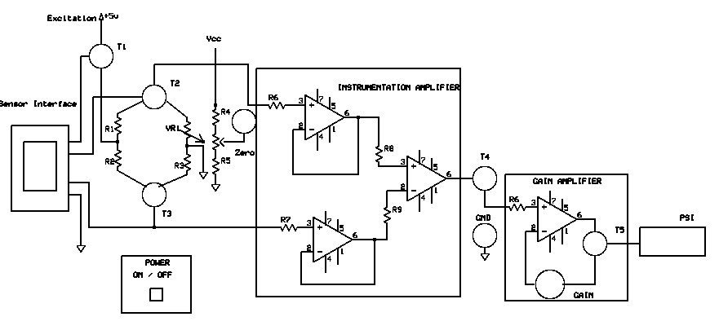
TABULAR COLUMN:

S. No. | Gauge Pressure (Psi) | Displayed Pressure (Psi) | Bridge Voltage (mV) | Output Voltage (V) | %Error

MODEL GRAPH:

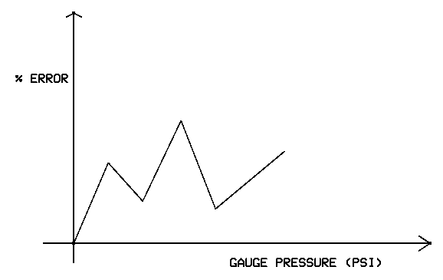

RESULT:

EXPT. NO 10 A/D CONVERTER

AIM
To study the working of successive approximation type Analog to Digital converter.

OBJECTIVE
- To study the conversion of analog i/p voltage to digital o/p voltage.
- To study the operation and characteristics of operational amplifier.

APPARATUS REQUIRED:

S.NO | NAME OF THE APPARATUS | RANGE | TYPE | QUANTITY
1  2  3  4 | A/D Converter kit  RPS  Multimeter  Connecting Wires

THEORY:

FORMULAE USED:

Input voltage, V_{in =} V_{ref} [D₇ 2⁻¹ + D₆ 2⁻² + D₅ 2⁻³ + ………. + D₀ 2⁻⁸]
Where,
V_{ref} = Reference voltage
D₇, D₆,D_{5,……}D₀ = 8 bit digital output
D₇ - MSB of digital data
D₀ – LSB of digital data

CIRCUIT DIAGRAM:

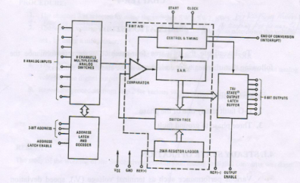

TABULAR COLUMN:
Reference Voltage –
SW1 =0 SW2 = 1 SW3=1
Analog input voltage |  | Digital output
Theoretical | Practical | D₇ | D₆ |  | D₅ | D₄ |  | D₃ | D₂ |  | D₁ | D₀
PROCEDURE:
- The channel 3 is selected by using switches SW1, SW2, SW3 by keeping them in 011 position.
- V_{ref} is measured using multi meter across pin 6 and 1 by keeping the pot at maximum position.
- The analog voltage to be converted is set by using the pot and the voltage set is measured by using multi meter.
- The ALE switch SW5 is pressed once to send the data to SAR.
- The SOC switch SW4 is pressed once to obtain the digital data for the given input voltage. The digital output obtained is noted.
- The procedure is repeated from step 2 for various values of analog input voltage.

RESULT:

EXPT. NO. 11 D/A CONVERTER

AIM
To study the working of an 8 bit weighted resistor type Digital to Analog converter.
OBJECTIVE
- To study the conversion of binary voltage to analog o/p voltage
- To study the operation and characteristics of operational amplifier

APPRATUS REQUIRED:

S.NO | NAME OF THE APPRATUS | RANGE | TYPE QTY
1  2  3  4 | D/A Converter kit  RPS  Multimeter  Connecting Wires

THEORY:

FORMULAE USED:

E_{o} = V_{ref} [(2 X_{o} – 255) / 256]
Where X_{o} is the equivalent decimal value of the given digital output.

CIRCUIT DIAGRAM:
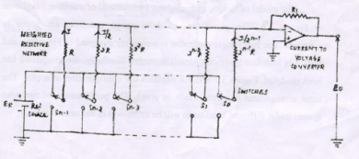

PROCEDURE:
- The connections are made as per the circuit diagram.
- V_{ref} is measured across P2 terminal by keeping the pot knob in maximum position.
- The binary input is applied by closing the appropriate switches.
- The analog output across P2 terminal by using multi meter.
- The procedure is repeated for various binary input values.

TABULAR COLUMN:

S.No. | Digital Input |  | Analog output
S.No. | Binary | Decimal equivalent | Theoretical |  | Practical

RESULT:

EXPT.NO. 12 STUDY OF TRANSIENTS
- RC TRANSIENTS:
AIM
To Observe and plot the transients waveform for a series RC circuit and compute the time constant.
OBJECTIVE
- To study the transient behaviour of the given system
- To study the effects of transients
APPRATUS REQUIRED:

S.NO | NAME OF THE APPRATUS | RANGE | TYPE QTY
1  2  3  4  5 | Resistance  Capacitance  Signal Generator  CRO & Probes  Bred board & Connecting Wires

NOTE
Choose the frequency (f) in signal generator such that f < (4τ ⁻¹ where τ =RC
CIRCUIT DIAGRAM:
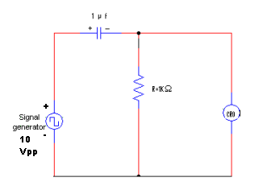

PROCEDURE:
- Connections are made as per the circuit diagram.
- Signal generator is adjusted for an input of 10 Vpp square wave and designed frequency and then applied to the circuit.
- The voltage across resistor , V_{R} = Ve^{- t/RC} is observed in the CRO and the time taken by the output to reach 36.8% of its final value (discharging time) is noted.

MODEL GRAPH:
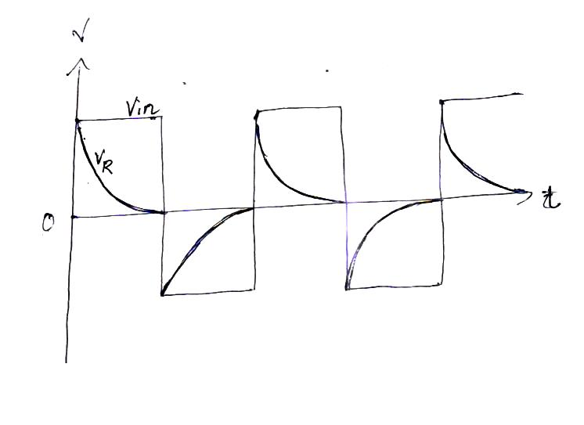

RESULT:

- RL TRANSIENTS:

AIM:
To observe and plot the transient waveform for a series RL circuit and to compute the time constant
OBJECTIVE
1. To study the transient behavior of the given system
2. To study the effects of transients
APPRATUS REQUIRED:

S.NO | NAME OF THE APPRATUS | RANGE | TYPE QTY
1  2  3  4  5 | Resistance  Inductor  Signal Generator  CRO & Probes  Bred board & Connecting Wires

NOTE
Choose the frequency (f) in signal generator such that f < (4 τ)⁻¹ where τ =L/R

CIRCUIT DIAGRAM:
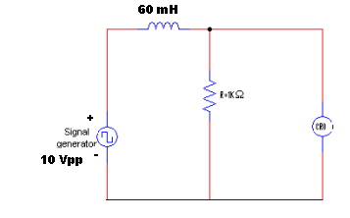
PROCEDURE:
- Connections are made as per the circuit diagram.
- Signal generator is adjusted for an input of 10 Vpp square wave and designed frequency and then applied to the circuit.
- The voltage across resistor , V_{R} =V ( 1 - e^{- tR/L}) is observed in the CRO and the time taken by the output to reach 63.2% of its final value (charging time) is noted.

MODEL GRAPH:
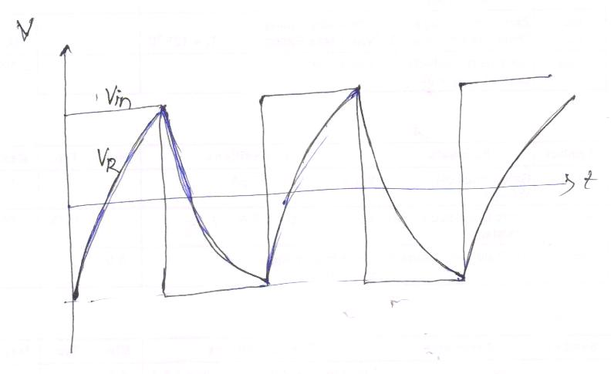

RESULT:

EXPT. NO. 13 CALIBRATION OF CURRENT TRANSFORMER

AIM
To study the working of current transformer

OBJECTIVE
- To study the current transformation concept
- To study the efficiency of a given current transformer
- To study the loss components in the circuit
APPRATUS REQUIRED:

S.NO | NAME OF THE APPRATUS | RANGE | TYPE QTY
1  2  3  4 | Current Transformer  Voltmeter  Ammeter  Resistive Load

THEORY:

FORMULAE USED:

% Ratio error =[( nominal ratio – actual ratio) / actual ratio] x 100

= [ (K_{n} - K_{act}) / K_{act} ]
Where
K_{act} = magnitude of actual primary current / magnitude of actual secondary current
K_{n} = rated primary current / rated secondary current
Inductive reactance in Ω, X_{L} = 2πfL
Where L is inductance of CT secondary in H
Impedance in Ω, Z = √ R² + X_{L}²
Secondary burden due to load, VA = I² Z

PRECAUTIONS:

- SPST 1 and SPST 2 should be kept closed before switching ON the supply.
- SPST2 should be opened before applying the load.

CIRCUIT DIAGRAM:
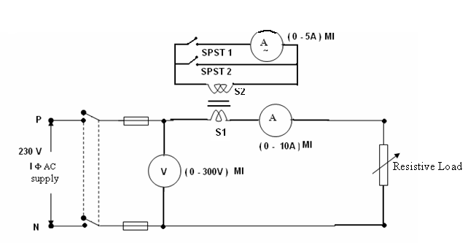

PROCEDURE:
- Connections are made as per the circuit diagram.
- DPST is closed on the primary side and no load voltage and current are noted.
- SPST 2 is opened and then load is applied in steps. For each load applied, line voltage, primary current, secondary current, and load values are noted down. Also resistance and inductance values of CT secondary are measured using LCR meter.
- The % error and secondary burden due to lad are calculated.
- A graph is drawn between primary current and secondary current is drawn.

TABULAR COLUMN:

S. No | Line voltage  V | Primary current  A | Secondary current  A | Load  W | R  Ω | L  H | Z  Ω | %  Error  % | Secondary burden due to load  VA

MODEL GRAPH:

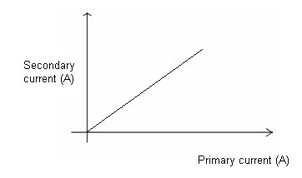

RESULT:
EXPT. NO. 14 MEASUREMENT OF IRON LOSS (MAXWELL BRIDGE)

AIM
To measure the iron loss of a given ring specimen
OBJECTIVE
- To study about hysterisis loss
- To study about eddy current loss
APPRATUS REQUIRED:

S.NO | NAME OF THE APPRATUS | RANGE | TYPE QTY
1  2  3  4 | Measurement of iron loss trainer  Ring Specimen  Multimeter  CRO

THEORY:

FORMULAE USED:
1. Unknown resistance, R₁=R₂R₃ / R₄ (Ω)
2. Unknown Inductance, L₁=R₂R₃C₄ Henry
3. Iron loss = I₁² x (R₁ – R_{w})
Where,
R_{w} is the winding resistance of the ring specimen measured using multimeter.

CIRCUIT DIAGRAM:
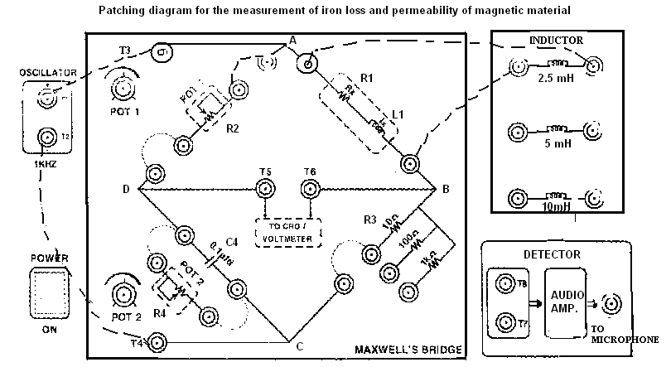
PROCEDURE:
- Patch the circuit as per the circuit diagram
- The pot 2(R₄) is kept in the maximum position and R3 is selected as 10 Ω initially.
- The trainer kit is switched ON
- Adjust pot 1 (R2) and obtain the null position in the CRO.
- At the bridge balance condition note down the current I₁ using multi meter(in mA range selection) connected in series with R₃ .
- Switch OFF the trainer kit and note down the value of R₂ and winding resistance of ring specimen using multi meter.
- Steps 3 to 6 are repeated for other two settings of R₃.
- The entire procedure is repeated for other samples of ring specimens provided in the kit.

TABULAR COLUMN: R₄ = __________ (Ω)
S.No. | Specimen No. | R₂ (Ω) | R₃(Ω) | I₁ (mA) | R_{W}(Ω) | R₁(Ω) | L₁(H) | Iron loss (W)
1. | 1 |  | 10
2. |  |  | 100
3. |  |  | 1000
4. | 2 |  | 10
5. |  |  | 100
6. |  |  | 1000
7. | 3 |  | 10
8. |  |  | 100
9. |  |  | 1000

RESULT:

Faculty Name : Mrs. V. DEVI MAHESWARAN Designation: ASSISTANT PROFESSOR
Department : E.E.E. Faculty Code : EE48
Subject Name : M & I Laboratory Subject Code : 131353
Year : II Semester : III
Degree & Branch : B.E. – E.E.E. Batch : A2

MEASUREMENTS AND INSTRUMENTATION LABORATORY –131353

LIST OF EXPERIMENTS

S.NO | TITLE | PAGE NO
1 | MEASUREMENT OF RESISTANCE USING WHEATSTONE BRIDGE
2 | MEASUREMENT OF RESISTANCE USING KELVIN’S DOUBLE BRIDGE.
3 | MEASUREMENT OF CAPACITANCE USING SCHERING BRIDGE.
4 | MEASUREMENT OF INDUCTANCE USING MAXWELLS BRIDGE.
5 | CALIBRATION OF 1∅ ENERGYMETER.
6 | MEASUREMENT OF 3 PHASE POWER AND POWER FACTOR
7 | INSTRUMENTATION AMPLIFIER.
8 | STUDY OF DISPLACEMENT TRANSDUCER - LVDT
9 | STUDY OF PRESSURE TRANSDUCER
10 | A/D CONVERTER
11 | D/A CONVERTER
12 | STUDY OF TRANSIENTS
13 | CALIBRATION OF CURRENT TRANSFORMER
14 | MEASUREMENT OF IRON LOSS (MAXWELL BRIDGE)

EXPT. NO. 1 MEASUREMENT OF RESISTANCE USING
WHEATSTONE BRIDGE

AIM:
To measure the given medium resistance using Wheatstone bridge.

OBJECTIVE:
To study the working of bridge under balanced and unbalanced condition and to study the sensitivity of bridge.
APPARATUS REQUIRED:

SL.NO | NAME OF THE APPRATUS | RANGE | TYPE | QTY
1  2  3  4 | Wheat stone Bridge kit  Unknown resistance  Multimeter  Connecting Wires.

CIRCUIT DIAGRAM:

THEORY:

FORMULAE USED:
Unknown Resistance, R_{x} = (P/Q) S (Ω)
Where P, Q = Ratio Arms.
S = Variable resistance,
R_{x} = Unknown resistance.

PROCEDURE:
1. The resistance to be measured is connected between XX points in the bridge kit.
2. The P/Q ratio (multiplier) is initially kept at position ‘1’ and the deflection of the
galvanometer is observed by pressing both the battery and the galvanometer keys.
3. The S arm (X 1000Ω) is adjusted and two positions are identified for which the
deflection of the galvanometer is on either side of the null point and kept at the lowest
value of S. Then the x100Ω, x10Ω, x1Ω knobs of S are adjusted to get null deflection.
If necessary the sensitivity knob may be adjusted to get appreciable deflection. [If not
possible P/Q ratio is kept at any other suitable value ie, any one of ratios provided.]
4. The value of unknown resistance is read. (S value)
5. Steps 3 and 4 are repeated for some other P/Q ratio. The mean value is taken.
6. The experiment is repeated with other samples provided.

NOTE: The above experiment may be used for measuring resistance of the samples less than 1Ω to greater than 10kΩ with lesser sensitivity.

TABULAR COLUMN:

S.NO | SAMPLE | P/Q RATIO  (MULTIPLIER) | S VALUE  (Ω) | UNKNOWN  RESISTANCE  R_{X} (Ω)

CALCULATION:

RESULT:

EXPT. NO. 2 MEASUREMENT OF RESISTANCE USING KELVIN’S DOUBLE BRIDGE

AIM:
To measure the given low resistance using Kelvin’s double bridge method.

OBJECTIVE:
To study the working of bridge under balanced and unbalanced condition and to study the sensitivity of bridge.
APPARATUS REQUIRED:

SL.NO | NAME OF THE APPRATUS | RANGE | TYPE | QTY
1  2  3  4 | Kelvin Double bridge kit Unknown resistance  Multimeter  Connecting Wires

CIRCUIT DIAGRAM:

THEORY:

FORMULA USED:

R_{x} = (P/Q) S ohms
Where
P, Q → first set of ratio arms.
p, q → Second set of ratio arms.
S → Standard resistance,
R_{x} → unknown resistance.

PROCEDURE:

1. The resistance to be measured is connected such that the leads from +C and + P are
connected to one end and those from –C and –P are connected to the other end in the
kit.
2. The P/Q ratio (multiplier) is initially kept at position ‘1’ and the deflection of the
galvanometer is observed by pressing the galvanometer key.
3. The ‘S’ arm (main dial) is adjusted and two positions are identified for which the
deflection of the galvanometer is on either side of the null point. [If not some other P/Q
ratio is to be tried].
4. The lowest of the two position indicates the coarse value of the unknown resistance
and the null point is obtained by adjusting the Vernier scale, with the galvanometer
sensitivity knob at the maximum position.
5. The value of unknown resistance is read. [‘S’ Value]
6. Steps 3, 4, 5 are repeated for some other P/Q ratio for the unknown resistance. The
mean value is taken.
7. The above procedure is repeated with another sample.

TABULAR COLUMN:

S.NO | SAMPLE | P/Q RATIO  (Multiplier) | S VALUE  COARSE(Ω) FINE ( Ω) | UNKNOWN RESISTANCE  R_{x} (Ω)
.
CALCULATION:

RESULT:

EXPT. NO. 3 MEASUREMENT OF CAPACITANCE USING
SCHERING BRIDGE

AIM:
To measure the unknown capacitance using Schering bridge.

OBJECTIVE:
To measure the unknown capacitance and to study about dissipation factor.
APPARATUS REQUIRED:

SL.NO | NAME OF THE APPRATUS | RANGE | TYPE | QTY
1  2  3  4  5 | Schering Bridge kit Unknown capacitance  Multimeter  Connecting Wires  CRO

CIRCUIT DIAGRAM:

THEORY:

FORMULA USED:

1. Unknown capacitance, C_{x} = (R₁/R₂) C₃,
Where C₃ is known capacitance in µF
R₂ is Non-Inductive Variable Resistor
2. Dissipation factor, D = ω R₁ C₁ = ω R_{x} C_{x}

PROCEDURE:

- The oscillator AB and the bridge AB terminals are connected.
- From the CD terminals of the bridge, the detector (loudspeaker) is connected through an imbalance amplifier.
- Connections of the bridge arm are made as per the circuit diagram.
- The value of R₂ is selected arbitrarily (say1K) and R₁ is kept at maximum position.
- The kit is switched on and R1 is decreased until the null point is observed as a dip in the sound from the loudspeaker.
- The capacitor C₁ can be varied for fine balance adjustment.
- When the balance condition is reached, the trainer kit is switched OFF and the value R₁ is measured using a multimeter.
- The value of unknown capacitance and dissipation factor is calculated.
- The experiment is repeated for various samples provided.

TABULAR COLUMN:

S.NO | SAMPLE | R₂ (Ω) | R₁ (Ω) | UNKNOWN CAPACITANCE C_{x} (µF)

CALCULATION:

RESULT:

EXPT. NO. 4 MEASUREMENT OF INDUCTANCE USING
MAXWELLS BRIDGE

AIM:
To find the unknown inductance and Q factor of a given coil.

OBJECTIVE:
To find the unknown inductance of the given coil using bridge circuit and to study that Maxwell inductance- capacitance bridge is suitable for the measurement of low Q coils.

APPARATUS REQUIRED:

SL.NO | NAME OF THE APPRATUS | RANGE | TYPE | QTY
1  2  3  4  5  6 | Maxwell’s inductance Capacitance Bridge kit  Unknown Inductance  Multimeter  Connecting Wires  CRO  Bridge oscillator | 1 kHZ

CIRCUIT DIAGRAM:

R3
L1
R1
D
C4

R2
R4

THEORY:

FORMULAE USED:

1. Unknown resistance, R₁=R₂R₃ / R₄ (Ω)
2. Unknown Inductance, L₁=R₂R₃C₄ Henry
Thus we have two variables R4 and C4 which appears in one of the two balance equation and hence the two equations are independent, and balance is obtained by varying R4 and C4 alternately.
3. Quality factor, Q = ωL₁ / R₁ = ωC₄R₄

PROCEDURE:
- The inductance to be measured is connected between L1 terminal of the kit.
- The bridge oscillator is set for 10Vpp, 1 kHz and connected to the OSC terminal of the kit.
- The detector CRO or headphone is connected to the headphone terminal of the kit.
- The R4 and C4 are adjusted from the highest range (among the 3 range knobs) to obtain the null point in the detector. [ Null point – For increase in R4 and C4 values the point at which the amplitude reduces to a minimum and then increases is null point).
- At the null point the values of R4 and C4 are noted.
- The value of unknown resistance, inductance and quality factor are calculated.
- The experiment is repeated with other samples provided.

TABULAR COLUMN:

S.NO | SAMPLE | R₄(Ω) | C₄ (F) | UNKNOWN INDUCTANCE  (H)

CALCULATION:

RESULT:

EXPT. NO. 5 CALIBRATION OF SINGLE PHASE ENERGYMETER

AIM:

To calibrate the given single phase energy meter at unity and other power factors

OBJECTIVE:
- To study the working of energy meter.
- To accurately calibrate the meter at unity and other power factor.
- To study the % of error for the given energy meter.
APPARATUS REQUIRED:

SL.NO | NAME OF THE APPRATUS | RANGE | TYPE | QTY
1  2  3  4  5  6 | Energy meter  Wattmeter  Ammeter  Voltmeter  Stop watch  Connecting Wires

CIRCUIT DIAGRAM:

NAME PLATE DETAILS:
RATED CURRENT
RATED VOLTAGE
FREQUENCY
REVOLUTIONS/KWH

THEORY:

FORMULAE USED:
Let x revolution / kwh be the rating.
Now x revolution = 1 kwh
= 1* 3600*1000 watt-sec.
Constant k of energymeter = 3600 * 10³/ x watt-sec
For each load, indicated power Wi is given as Wi = k/t watts
Where
K= energy meter constant (watt-sec)
t = time for 1 revolution(sec)
% error = Wi – Wa / Wi * 100
Where Wi is indicated power in watts
Wa is actual power shown by wattmeter in watts

% error can be zero +ve or –ve.

PROCEDURE:

1. Connections are given as shown in the circuit diagram.
2. Supply is switched ON and load is increased in steps, each time noting the readings of
ammeter and wattmeter. Also the actual time taken for 1 revolution of the disc is
measured using stop watch.
3. Step 2 is repeated till rated current of the energy meter is reached.
4. % error is calculated and calibration curve is drawn.

TABULAR COLUMN:

S.NO | LOAD CURRENT  I (Amps) | WATTMETER  READING, Wa (W) | INDICATED  POWER, Wi (W) | Time taken , t (secs) | % ERROR

CALCULATION:

MODEL GRAPH:

+Ve
% Error
0
Wi

-Ve

NOTE:
From the calibration curve it is possible to predict the error in recording the energy. So the correction can be applied to the energy meter reading so that correct energy reading can be obtained and used.

RESULT:

EXPT. NO. 6 MEASUREMENT OF THREE PHASE POWER
AND POWER FACTOR

AIM
To conduct a suitable experiment on a 3-phase load connected in star or delta to measure the three phase power and power factor using 2 wattmeter method.

OBJECTIVES
- To study the working of wattmeter
- To accurately measure the 3 phase power
- To accurately measure the power factor
- To study the concept of star connected load and delta connected load
APPARATUS REQUIRED:

S.NO | NAME OF THE APPRATUS | RANGE | TYPE QTY
1  2  3  4  5 | Ammeter  Voltmeter  Wattmeter  Connecting Wires  3 phase inductive load
CIRCUIT DIAGRAM:

THEORY:

FORMULA USED:

- Total power, P = W1+W2 (W)
- φ= Tan-1 √3 [(W1-W2) /(W1+W2)]
3. P.F = Cosφ

PROCEDURE:

- Connection are made as per the circuit diagram, keeping the inductive load in the
initial position.
- Supply switch is closed and reading of ammeter and wattmeter are noted .If one of the wattmeter reads negative, then its potential coils (C and V) are interchanged and
reading is taken as negative.
3. The above procedure is repeated for different values of inductive coil. Care should be
taken that current should not exceed 10A during the experiment.

TABULAR COLUMN:

S.NO | I | W1 | W2 | POWER, P | P.F  Cosφ
 | (Amps) | (Watts) | (Watts) | (Watts)

CALCULATION:

RESULT:

EXPT. NO. 7 INSTRUMENTATION AMPLIFIER.

AIM:
To study the working of instrumentation amplifier.

OBJECTIVE:

- To study the characteristic of operational amplifier.
- To study the use of operational amplifier as instrumentation amplifier.
APPARATUS REQUIRED:

S.NO | NAME OF THE APPRATUS | RANGE | TYPE QTY
1  2  3  4 | Instrumentation Amplifier Kit  Dual RPS  Multi meter  Connecting Wires

PIN DIAGRAM:
PIN DIAGRAM OF IC741

CIRCUIT DIAGRAM:
R1 = R2 = R

THEORY:

FORMULAE USED:
- Vo= (V2 – V1) (1 + 2R / Rg)

PROCEDURE:

- Connect a dual RPS to the input terminals V1 and V2 of either channel 1 or channel 2 of instrumentation amplifier module.
- Adjust the RPS for different voltages for V1 and V2 (not more than 10 V).
- Measure the output voltage using a multi meter for every set of V1 and V2.

TABULAR COLUMN:

V₁ (v) | V₂ (v) | V_{out} (v)

RESULT:
EXPT. NO. 8 STUDY OF DISPLACEMENT TRANSDUCER - LVDT

AIM
To study the operation of LVDT- Linear Variable Differential Transformer

OBJECTIVE:
- To study the basic principle of LVDT.

- Study of signal conditioning circuit.

3. Study of LVDT as transducer.

APPARATUS REQUIRED:

S.NO | NAME OF THE APPRATUS | RANGE | TYPE QTY
1  2  3  4 | LVDT kit  Multimeter  Connecting Wires

THEORY:

CIRCUIT DIAGRAM:

Fig.1
Fig.2

PATCHING DIAGRAM:

PROCEDURE:
- The trainer is switched and power supply is checked for +12V and -12Vwith the help of multi meter.
- The trainer is switched off and connections are made as per the patching diagram.
- The LVDT is connected in the kit through connector provided in the circuit.
- The displacement of LVDT is kept at one end by using screw guage.
- The trainer is switched on and the output DC voltage is measured using multimeter by connecting it across DC output + and – respectively.
- The displacement is varied with the help of screw gauge and the corresponding output voltages are noted down.
- The screw gauge is adjusted for maximum displacement and then stopped.
- A graph between displacement and output voltage is drawn.

TABULAR COLUMN:

S.NO | DISPLACEMENT ON  MICRO-METER (mm) | MULTIMETER READING (Volts)

MODEL GRAPH:
RESULT:

EXPT. NO 9 STUDY OF PRESSURE TRANSDUCER

AIM
To study the operation of a pressure transducer – Strain gauge.

OBJECTIVES
- To study the basic principle of Strain gauge.

- Study of Strain gauge as transducer.

APPARATUS REQUIRED:
S.NO | NAME OF THE APPARATUS | RANGE | TYPE | QUANTITY
1  2 | Pressure measurement module  Multimeter

THEORY:

FORMULAE USED:

% Error = [(Gauge pressure – displayed pressure) / displayed pressure] * 100

PROCEDURE:

- Install the pressure cell setup and interface the 9 pin D connector with the pressure measurement module. Switch ON the module.
- Calibrate the pressure measurement module by the following procedure. Open the air release valve and exhaust the tank inlet air and nullify the output voltage by using zero adjustment pot, then close the air release valve and apply 20 Psi pressure to the cylinder and adjust the display to 20 Psi by using gain adjustment POT.
- After calibration open the air release valve and exhaust the tank inlet air.
- Close the air release valve and press the pump piston and note down the bridge voltage in mV across T2 and T3, output voltage in V across T5 and GND and the displayed pressure in Psi in the indicator. Repeat the procedure for increasing values of pressure and tabulate the readings.(Pressure should not exceed 20 Psi)
- Plot the error calibration curve.

CIRCUIT DIAGRAM:

TABULAR COLUMN:

S. No. | Gauge Pressure (Psi) | Displayed Pressure (Psi) | Bridge Voltage (mV) | Output Voltage (V) | %Error

MODEL GRAPH:

RESULT:

EXPT. NO 10 A/D CONVERTER

AIM
To study the working of successive approximation type Analog to Digital converter.

OBJECTIVE
- To study the conversion of analog i/p voltage to digital o/p voltage.
- To study the operation and characteristics of operational amplifier.

APPARATUS REQUIRED:

S.NO | NAME OF THE APPARATUS | RANGE | TYPE | QUANTITY
1  2  3  4 | A/D Converter kit  RPS  Multimeter  Connecting Wires

THEORY:

FORMULAE USED:

Input voltage, V_{in =} V_{ref} [D₇ 2⁻¹ + D₆ 2⁻² + D₅ 2⁻³ + ………. + D₀ 2⁻⁸]
Where,
V_{ref} = Reference voltage
D₇, D₆,D_{5,……}D₀ = 8 bit digital output
D₇ - MSB of digital data
D₀ – LSB of digital data

CIRCUIT DIAGRAM:

TABULAR COLUMN:
Reference Voltage –
SW1 =0 SW2 = 1 SW3=1
Analog input voltage |  | Digital output
Theoretical | Practical | D₇ | D₆ |  | D₅ | D₄ |  | D₃ | D₂ |  | D₁ | D₀
PROCEDURE:
- The channel 3 is selected by using switches SW1, SW2, SW3 by keeping them in 011 position.
- V_{ref} is measured using multi meter across pin 6 and 1 by keeping the pot at maximum position.
- The analog voltage to be converted is set by using the pot and the voltage set is measured by using multi meter.
- The ALE switch SW5 is pressed once to send the data to SAR.
- The SOC switch SW4 is pressed once to obtain the digital data for the given input voltage. The digital output obtained is noted.
- The procedure is repeated from step 2 for various values of analog input voltage.

RESULT:

EXPT. NO. 11 D/A CONVERTER

AIM
To study the working of an 8 bit weighted resistor type Digital to Analog converter.
OBJECTIVE
- To study the conversion of binary voltage to analog o/p voltage
- To study the operation and characteristics of operational amplifier

APPRATUS REQUIRED:

S.NO | NAME OF THE APPRATUS | RANGE | TYPE QTY
1  2  3  4 | D/A Converter kit  RPS  Multimeter  Connecting Wires

THEORY:

FORMULAE USED:

E_{o} = V_{ref} [(2 X_{o} – 255) / 256]
Where X_{o} is the equivalent decimal value of the given digital output.

CIRCUIT DIAGRAM:

PROCEDURE:
- The connections are made as per the circuit diagram.
- V_{ref} is measured across P2 terminal by keeping the pot knob in maximum position.
- The binary input is applied by closing the appropriate switches.
- The analog output across P2 terminal by using multi meter.
- The procedure is repeated for various binary input values.

TABULAR COLUMN:

S.No. | Digital Input |  | Analog output
S.No. | Binary | Decimal equivalent | Theoretical |  | Practical

RESULT:

EXPT.NO. 12 STUDY OF TRANSIENTS
- RC TRANSIENTS:
AIM
To Observe and plot the transients waveform for a series RC circuit and compute the time constant.
OBJECTIVE
- To study the transient behaviour of the given system
- To study the effects of transients
APPRATUS REQUIRED:

S.NO | NAME OF THE APPRATUS | RANGE | TYPE QTY
1  2  3  4  5 | Resistance  Capacitance  Signal Generator  CRO & Probes  Bred board & Connecting Wires

NOTE
Choose the frequency (f) in signal generator such that f < (4τ ⁻¹ where τ =RC
CIRCUIT DIAGRAM:

PROCEDURE:
- Connections are made as per the circuit diagram.
- Signal generator is adjusted for an input of 10 Vpp square wave and designed frequency and then applied to the circuit.
- The voltage across resistor , V_{R} = Ve^{- t/RC} is observed in the CRO and the time taken by the output to reach 36.8% of its final value (discharging time) is noted.

MODEL GRAPH:

RESULT:

- RL TRANSIENTS:

AIM:
To observe and plot the transient waveform for a series RL circuit and to compute the time constant
OBJECTIVE
1. To study the transient behavior of the given system
2. To study the effects of transients
APPRATUS REQUIRED:

S.NO | NAME OF THE APPRATUS | RANGE | TYPE QTY
1  2  3  4  5 | Resistance  Inductor  Signal Generator  CRO & Probes  Bred board & Connecting Wires

NOTE
Choose the frequency (f) in signal generator such that f < (4 τ)⁻¹ where τ =L/R

CIRCUIT DIAGRAM:
PROCEDURE:
- Connections are made as per the circuit diagram.
- Signal generator is adjusted for an input of 10 Vpp square wave and designed frequency and then applied to the circuit.
- The voltage across resistor , V_{R} =V ( 1 - e^{- tR/L}) is observed in the CRO and the time taken by the output to reach 63.2% of its final value (charging time) is noted.

MODEL GRAPH:

RESULT:

EXPT. NO. 13 CALIBRATION OF CURRENT TRANSFORMER

AIM
To study the working of current transformer

OBJECTIVE
- To study the current transformation concept
- To study the efficiency of a given current transformer
- To study the loss components in the circuit
APPRATUS REQUIRED:

S.NO | NAME OF THE APPRATUS | RANGE | TYPE QTY
1  2  3  4 | Current Transformer  Voltmeter  Ammeter  Resistive Load

THEORY:

FORMULAE USED:

% Ratio error =[( nominal ratio – actual ratio) / actual ratio] x 100

= [ (K_{n} - K_{act}) / K_{act} ]
Where
K_{act} = magnitude of actual primary current / magnitude of actual secondary current
K_{n} = rated primary current / rated secondary current
Inductive reactance in Ω, X_{L} = 2πfL
Where L is inductance of CT secondary in H
Impedance in Ω, Z = √ R² + X_{L}²
Secondary burden due to load, VA = I² Z

PRECAUTIONS:

- SPST 1 and SPST 2 should be kept closed before switching ON the supply.
- SPST2 should be opened before applying the load.

CIRCUIT DIAGRAM:

PROCEDURE:
- Connections are made as per the circuit diagram.
- DPST is closed on the primary side and no load voltage and current are noted.
- SPST 2 is opened and then load is applied in steps. For each load applied, line voltage, primary current, secondary current, and load values are noted down. Also resistance and inductance values of CT secondary are measured using LCR meter.
- The % error and secondary burden due to lad are calculated.
- A graph is drawn between primary current and secondary current is drawn.

TABULAR COLUMN:

S. No | Line voltage  V | Primary current  A | Secondary current  A | Load  W | R  Ω | L  H | Z  Ω | %  Error  % | Secondary burden due to load  VA

MODEL GRAPH:

RESULT:
EXPT. NO. 14 MEASUREMENT OF IRON LOSS (MAXWELL BRIDGE)

AIM
To measure the iron loss of a given ring specimen
OBJECTIVE
- To study about hysterisis loss
- To study about eddy current loss
APPRATUS REQUIRED:

S.NO | NAME OF THE APPRATUS | RANGE | TYPE QTY
1  2  3  4 | Measurement of iron loss trainer  Ring Specimen  Multimeter  CRO

THEORY:

FORMULAE USED:
1. Unknown resistance, R₁=R₂R₃ / R₄ (Ω)
2. Unknown Inductance, L₁=R₂R₃C₄ Henry
3. Iron loss = I₁² x (R₁ – R_{w})
Where,
R_{w} is the winding resistance of the ring specimen measured using multimeter.

CIRCUIT DIAGRAM:
PROCEDURE:
- Patch the circuit as per the circuit diagram
- The pot 2(R₄) is kept in the maximum position and R3 is selected as 10 Ω initially.
- The trainer kit is switched ON
- Adjust pot 1 (R2) and obtain the null position in the CRO.
- At the bridge balance condition note down the current I₁ using multi meter(in mA range selection) connected in series with R₃ .
- Switch OFF the trainer kit and note down the value of R₂ and winding resistance of ring specimen using multi meter.
- Steps 3 to 6 are repeated for other two settings of R₃.
- The entire procedure is repeated for other samples of ring specimens provided in the kit.

TABULAR COLUMN: R₄ = __________ (Ω)
S.No. | Specimen No. | R₂ (Ω) | R₃(Ω) | I₁ (mA) | R_{W}(Ω) | R₁(Ω) | L₁(H) | Iron loss (W)
1. | 1 |  | 10
2. |  |  | 100
3. |  |  | 1000
4. | 2 |  | 10
5. |  |  | 100
6. |  |  | 1000
7. | 3 |  | 10
8. |  |  | 100
9. |  |  | 1000

RESULT:

Faculty Name : Mrs. P.T. SUBASINI Designation: LECTURER
Department : E.E.E. Faculty Code : EE 41
Subject Name : M & I Laboratory Subject Code : 131353
Year : II Semester : III
Degree & Branch : B.E. – E.E.E. Batch : B1

MEASUREMENTS AND INSTRUMENTATION LABORATORY –131353

LIST OF EXPERIMENTS

S.NO | TITLE | PAGE NO
1 | MEASUREMENT OF RESISTANCE USING WHEATSTONE BRIDGE
2 | MEASUREMENT OF RESISTANCE USING KELVIN’S DOUBLE BRIDGE.
3 | MEASUREMENT OF CAPACITANCE USING SCHERING BRIDGE.
4 | MEASUREMENT OF INDUCTANCE USING MAXWELLS BRIDGE.
5 | CALIBRATION OF 1∅ ENERGYMETER.
6 | MEASUREMENT OF 3 PHASE POWER AND POWER FACTOR
7 | INSTRUMENTATION AMPLIFIER.
8 | STUDY OF DISPLACEMENT TRANSDUCER - LVDT
9 | STUDY OF PRESSURE TRANSDUCER
10 | A/D CONVERTER
11 | D/A CONVERTER
12 | STUDY OF TRANSIENTS
13 | CALIBRATION OF CURRENT TRANSFORMER
14 | MEASUREMENT OF IRON LOSS (MAXWELL BRIDGE)

EXPT. NO. 1 MEASUREMENT OF RESISTANCE USING
WHEATSTONE BRIDGE

AIM:
To measure the given medium resistance using Wheatstone bridge.

OBJECTIVE:
To study the working of bridge under balanced and unbalanced condition and to study the sensitivity of bridge.
APPARATUS REQUIRED:

SL.NO | NAME OF THE APPRATUS | RANGE | TYPE | QTY
1  2  3  4 | Wheat stone Bridge kit  Unknown resistance  Multimeter  Connecting Wires.

CIRCUIT DIAGRAM:

THEORY:

FORMULAE USED:
Unknown Resistance, R_{x} = (P/Q) S (Ω)
Where P, Q = Ratio Arms.
S = Variable resistance,
R_{x} = Unknown resistance.

PROCEDURE:
1. The resistance to be measured is connected between XX points in the bridge kit.
2. The P/Q ratio (multiplier) is initially kept at position ‘1’ and the deflection of the
galvanometer is observed by pressing both the battery and the galvanometer keys.
3. The S arm (X 1000Ω) is adjusted and two positions are identified for which the
deflection of the galvanometer is on either side of the null point and kept at the lowest
value of S. Then the x100Ω, x10Ω, x1Ω knobs of S are adjusted to get null deflection.
If necessary the sensitivity knob may be adjusted to get appreciable deflection. [If not
possible P/Q ratio is kept at any other suitable value ie, any one of ratios provided.]
4. The value of unknown resistance is read. (S value)
5. Steps 3 and 4 are repeated for some other P/Q ratio. The mean value is taken.
6. The experiment is repeated with other samples provided.

NOTE: The above experiment may be used for measuring resistance of the samples less than 1Ω to greater than 10kΩ with lesser sensitivity.

TABULAR COLUMN:

S.NO | SAMPLE | P/Q RATIO  (MULTIPLIER) | S VALUE  (Ω) | UNKNOWN  RESISTANCE  R_{X} (Ω)

CALCULATION:

RESULT:

EXPT. NO. 2 MEASUREMENT OF RESISTANCE USING KELVIN’S DOUBLE BRIDGE

AIM:
To measure the given low resistance using Kelvin’s double bridge method.

OBJECTIVE:
To study the working of bridge under balanced and unbalanced condition and to study the sensitivity of bridge.
APPARATUS REQUIRED:

SL.NO | NAME OF THE APPRATUS | RANGE | TYPE | QTY
1  2  3  4 | Kelvin Double bridge kit Unknown resistance  Multimeter  Connecting Wires

CIRCUIT DIAGRAM:

THEORY:

FORMULA USED:

R_{x} = (P/Q) S ohms
Where
P, Q → first set of ratio arms.
p, q → Second set of ratio arms.
S → Standard resistance,
R_{x} → unknown resistance.

PROCEDURE:

1. The resistance to be measured is connected such that the leads from +C and + P are
connected to one end and those from –C and –P are connected to the other end in the
kit.
2. The P/Q ratio (multiplier) is initially kept at position ‘1’ and the deflection of the
galvanometer is observed by pressing the galvanometer key.
3. The ‘S’ arm (main dial) is adjusted and two positions are identified for which the
deflection of the galvanometer is on either side of the null point. [If not some other P/Q
ratio is to be tried].
4. The lowest of the two position indicates the coarse value of the unknown resistance
and the null point is obtained by adjusting the Vernier scale, with the galvanometer
sensitivity knob at the maximum position.
5. The value of unknown resistance is read. [‘S’ Value]
6. Steps 3, 4, 5 are repeated for some other P/Q ratio for the unknown resistance. The
mean value is taken.
7. The above procedure is repeated with another sample.

TABULAR COLUMN:

S.NO | SAMPLE | P/Q RATIO  (Multiplier) | S VALUE  COARSE(Ω) FINE ( Ω) | UNKNOWN RESISTANCE  R_{x} (Ω)
.
CALCULATION:

RESULT:

EXPT. NO. 3 MEASUREMENT OF CAPACITANCE USING
SCHERING BRIDGE

AIM:
To measure the unknown capacitance using Schering bridge.

OBJECTIVE:
To measure the unknown capacitance and to study about dissipation factor.
APPARATUS REQUIRED:

SL.NO | NAME OF THE APPRATUS | RANGE | TYPE | QTY
1  2  3  4  5 | Schering Bridge kit Unknown capacitance  Multimeter  Connecting Wires  CRO

CIRCUIT DIAGRAM:

THEORY:

FORMULA USED:

1. Unknown capacitance, C_{x} = (R₁/R₂) C₃,
Where C₃ is known capacitance in µF
R₂ is Non-Inductive Variable Resistor
2. Dissipation factor, D = ω R₁ C₁ = ω R_{x} C_{x}

PROCEDURE:

- The oscillator AB and the bridge AB terminals are connected.
- From the CD terminals of the bridge, the detector (loudspeaker) is connected through an imbalance amplifier.
- Connections of the bridge arm are made as per the circuit diagram.
- The value of R₂ is selected arbitrarily (say1K) and R₁ is kept at maximum position.
- The kit is switched on and R1 is decreased until the null point is observed as a dip in the sound from the loudspeaker.
- The capacitor C₁ can be varied for fine balance adjustment.
- When the balance condition is reached, the trainer kit is switched OFF and the value R₁ is measured using a multimeter.
- The value of unknown capacitance and dissipation factor is calculated.
- The experiment is repeated for various samples provided.

TABULAR COLUMN:

S.NO | SAMPLE | R₂ (Ω) | R₁ (Ω) | UNKNOWN CAPACITANCE C_{x} (µF)

CALCULATION:

RESULT:

EXPT. NO. 4 MEASUREMENT OF INDUCTANCE USING
MAXWELLS BRIDGE

AIM:
To find the unknown inductance and Q factor of a given coil.

OBJECTIVE:
To find the unknown inductance of the given coil using bridge circuit and to study that Maxwell inductance- capacitance bridge is suitable for the measurement of low Q coils.

APPARATUS REQUIRED:

SL.NO | NAME OF THE APPRATUS | RANGE | TYPE | QTY
1  2  3  4  5  6 | Maxwell’s inductance Capacitance Bridge kit  Unknown Inductance  Multimeter  Connecting Wires  CRO  Bridge oscillator | 1 kHZ

CIRCUIT DIAGRAM:

R3
L1
R1
D
C4

R2
R4

THEORY:

FORMULAE USED:

1. Unknown resistance, R₁=R₂R₃ / R₄ (Ω)
2. Unknown Inductance, L₁=R₂R₃C₄ Henry
Thus we have two variables R4 and C4 which appears in one of the two balance equation and hence the two equations are independent, and balance is obtained by varying R4 and C4 alternately.
3. Quality factor, Q = ωL₁ / R₁ = ωC₄R₄

PROCEDURE:
- The inductance to be measured is connected between L1 terminal of the kit.
- The bridge oscillator is set for 10Vpp, 1 kHz and connected to the OSC terminal of the kit.
- The detector CRO or headphone is connected to the headphone terminal of the kit.
- The R4 and C4 are adjusted from the highest range (among the 3 range knobs) to obtain the null point in the detector. [ Null point – For increase in R4 and C4 values the point at which the amplitude reduces to a minimum and then increases is null point).
- At the null point the values of R4 and C4 are noted.
- The value of unknown resistance, inductance and quality factor are calculated.
- The experiment is repeated with other samples provided.

TABULAR COLUMN:

S.NO | SAMPLE | R₄(Ω) | C₄ (F) | UNKNOWN INDUCTANCE  (H)

CALCULATION:

RESULT:

EXPT. NO. 5 CALIBRATION OF SINGLE PHASE ENERGYMETER

AIM:

To calibrate the given single phase energy meter at unity and other power factors

OBJECTIVE:
- To study the working of energy meter.
- To accurately calibrate the meter at unity and other power factor.
- To study the % of error for the given energy meter.
APPARATUS REQUIRED:

SL.NO | NAME OF THE APPRATUS | RANGE | TYPE | QTY
1  2  3  4  5  6 | Energy meter  Wattmeter  Ammeter  Voltmeter  Stop watch  Connecting Wires

CIRCUIT DIAGRAM:

NAME PLATE DETAILS:
RATED CURRENT
RATED VOLTAGE
FREQUENCY
REVOLUTIONS/KWH

THEORY:

FORMULAE USED:
Let x revolution / kwh be the rating.
Now x revolution = 1 kwh
= 1* 3600*1000 watt-sec.
Constant k of energymeter = 3600 * 10³/ x watt-sec
For each load, indicated power Wi is given as Wi = k/t watts
Where
K= energy meter constant (watt-sec)
t = time for 1 revolution(sec)
% error = Wi – Wa / Wi * 100
Where Wi is indicated power in watts
Wa is actual power shown by wattmeter in watts

% error can be zero +ve or –ve.

PROCEDURE:

1. Connections are given as shown in the circuit diagram.
2. Supply is switched ON and load is increased in steps, each time noting the readings of
ammeter and wattmeter. Also the actual time taken for 1 revolution of the disc is
measured using stop watch.
3. Step 2 is repeated till rated current of the energy meter is reached.
4. % error is calculated and calibration curve is drawn.

TABULAR COLUMN:

S.NO | LOAD CURRENT  I (Amps) | WATTMETER  READING, Wa (W) | INDICATED  POWER, Wi (W) | Time taken , t (secs) | % ERROR

CALCULATION:

MODEL GRAPH:

+Ve
% Error
0
Wi

-Ve

NOTE:
From the calibration curve it is possible to predict the error in recording the energy. So the correction can be applied to the energy meter reading so that correct energy reading can be obtained and used.

RESULT:

EXPT. NO. 6 MEASUREMENT OF THREE PHASE POWER
AND POWER FACTOR

AIM
To conduct a suitable experiment on a 3-phase load connected in star or delta to measure the three phase power and power factor using 2 wattmeter method.

OBJECTIVES
- To study the working of wattmeter
- To accurately measure the 3 phase power
- To accurately measure the power factor
- To study the concept of star connected load and delta connected load
APPARATUS REQUIRED:

S.NO | NAME OF THE APPRATUS | RANGE | TYPE QTY
1  2  3  4  5 | Ammeter  Voltmeter  Wattmeter  Connecting Wires  3 phase inductive load
CIRCUIT DIAGRAM:

THEORY:

FORMULA USED:

- Total power, P = W1+W2 (W)
- φ= Tan-1 √3 [(W1-W2) /(W1+W2)]
3. P.F = Cosφ

PROCEDURE:

- Connection are made as per the circuit diagram, keeping the inductive load in the
initial position.
- Supply switch is closed and reading of ammeter and wattmeter are noted .If one of the wattmeter reads negative, then its potential coils (C and V) are interchanged and
reading is taken as negative.
3. The above procedure is repeated for different values of inductive coil. Care should be
taken that current should not exceed 10A during the experiment.

TABULAR COLUMN:

S.NO | I | W1 | W2 | POWER, P | P.F  Cosφ
 | (Amps) | (Watts) | (Watts) | (Watts)

CALCULATION:

RESULT:

EXPT. NO. 7 INSTRUMENTATION AMPLIFIER.

AIM:
To study the working of instrumentation amplifier.

OBJECTIVE:

- To study the characteristic of operational amplifier.
- To study the use of operational amplifier as instrumentation amplifier.
APPARATUS REQUIRED:

S.NO | NAME OF THE APPRATUS | RANGE | TYPE QTY
1  2  3  4 | Instrumentation Amplifier Kit  Dual RPS  Multi meter  Connecting Wires

PIN DIAGRAM:
PIN DIAGRAM OF IC741

CIRCUIT DIAGRAM:
R1 = R2 = R

THEORY:

FORMULAE USED:
- Vo= (V2 – V1) (1 + 2R / Rg)

PROCEDURE:

- Connect a dual RPS to the input terminals V1 and V2 of either channel 1 or channel 2 of instrumentation amplifier module.
- Adjust the RPS for different voltages for V1 and V2 (not more than 10 V).
- Measure the output voltage using a multi meter for every set of V1 and V2.

TABULAR COLUMN:

V₁ (v) | V₂ (v) | V_{out} (v)

RESULT:
EXPT. NO. 8 STUDY OF DISPLACEMENT TRANSDUCER - LVDT

AIM
To study the operation of LVDT- Linear Variable Differential Transformer

OBJECTIVE:
- To study the basic principle of LVDT.

- Study of signal conditioning circuit.

3. Study of LVDT as transducer.

APPARATUS REQUIRED:

S.NO | NAME OF THE APPRATUS | RANGE | TYPE QTY
1  2  3  4 | LVDT kit  Multimeter  Connecting Wires

THEORY:

CIRCUIT DIAGRAM:

Fig.1
Fig.2

PATCHING DIAGRAM:

PROCEDURE:
- The trainer is switched and power supply is checked for +12V and -12Vwith the help of multi meter.
- The trainer is switched off and connections are made as per the patching diagram.
- The LVDT is connected in the kit through connector provided in the circuit.
- The displacement of LVDT is kept at one end by using screw guage.
- The trainer is switched on and the output DC voltage is measured using multimeter by connecting it across DC output + and – respectively.
- The displacement is varied with the help of screw gauge and the corresponding output voltages are noted down.
- The screw gauge is adjusted for maximum displacement and then stopped.
- A graph between displacement and output voltage is drawn.

TABULAR COLUMN:

S.NO | DISPLACEMENT ON  MICRO-METER (mm) | MULTIMETER READING (Volts)

MODEL GRAPH:
RESULT:

EXPT. NO 9 STUDY OF PRESSURE TRANSDUCER

AIM
To study the operation of a pressure transducer – Strain gauge.

OBJECTIVES
- To study the basic principle of Strain gauge.

- Study of Strain gauge as transducer.

APPARATUS REQUIRED:
S.NO | NAME OF THE APPARATUS | RANGE | TYPE | QUANTITY
1  2 | Pressure measurement module  Multimeter

THEORY:

FORMULAE USED:

% Error = [(Gauge pressure – displayed pressure) / displayed pressure] * 100

PROCEDURE:

- Install the pressure cell setup and interface the 9 pin D connector with the pressure measurement module. Switch ON the module.
- Calibrate the pressure measurement module by the following procedure. Open the air release valve and exhaust the tank inlet air and nullify the output voltage by using zero adjustment pot, then close the air release valve and apply 20 Psi pressure to the cylinder and adjust the display to 20 Psi by using gain adjustment POT.
- After calibration open the air release valve and exhaust the tank inlet air.
- Close the air release valve and press the pump piston and note down the bridge voltage in mV across T2 and T3, output voltage in V across T5 and GND and the displayed pressure in Psi in the indicator. Repeat the procedure for increasing values of pressure and tabulate the readings.(Pressure should not exceed 20 Psi)
- Plot the error calibration curve.

CIRCUIT DIAGRAM:

TABULAR COLUMN:

S. No. | Gauge Pressure (Psi) | Displayed Pressure (Psi) | Bridge Voltage (mV) | Output Voltage (V) | %Error

MODEL GRAPH:

RESULT:

EXPT. NO 10 A/D CONVERTER

AIM
To study the working of successive approximation type Analog to Digital converter.

OBJECTIVE
- To study the conversion of analog i/p voltage to digital o/p voltage.
- To study the operation and characteristics of operational amplifier.

APPARATUS REQUIRED:

S.NO | NAME OF THE APPARATUS | RANGE | TYPE | QUANTITY
1  2  3  4 | A/D Converter kit  RPS  Multimeter  Connecting Wires

THEORY:

FORMULAE USED:

Input voltage, V_{in =} V_{ref} [D₇ 2⁻¹ + D₆ 2⁻² + D₅ 2⁻³ + ………. + D₀ 2⁻⁸]
Where,
V_{ref} = Reference voltage
D₇, D₆,D_{5,……}D₀ = 8 bit digital output
D₇ - MSB of digital data
D₀ – LSB of digital data

CIRCUIT DIAGRAM:

TABULAR COLUMN:
Reference Voltage –
SW1 =0 SW2 = 1 SW3=1
Analog input voltage |  | Digital output
Theoretical | Practical | D₇ | D₆ |  | D₅ | D₄ |  | D₃ | D₂ |  | D₁ | D₀
PROCEDURE:
- The channel 3 is selected by using switches SW1, SW2, SW3 by keeping them in 011 position.
- V_{ref} is measured using multi meter across pin 6 and 1 by keeping the pot at maximum position.
- The analog voltage to be converted is set by using the pot and the voltage set is measured by using multi meter.
- The ALE switch SW5 is pressed once to send the data to SAR.
- The SOC switch SW4 is pressed once to obtain the digital data for the given input voltage. The digital output obtained is noted.
- The procedure is repeated from step 2 for various values of analog input voltage.

RESULT:

EXPT. NO. 11 D/A CONVERTER

AIM
To study the working of an 8 bit weighted resistor type Digital to Analog converter.
OBJECTIVE
- To study the conversion of binary voltage to analog o/p voltage
- To study the operation and characteristics of operational amplifier

APPRATUS REQUIRED:

S.NO | NAME OF THE APPRATUS | RANGE | TYPE QTY
1  2  3  4 | D/A Converter kit  RPS  Multimeter  Connecting Wires

THEORY:

FORMULAE USED:

E_{o} = V_{ref} [(2 X_{o} – 255) / 256]
Where X_{o} is the equivalent decimal value of the given digital output.

CIRCUIT DIAGRAM:

PROCEDURE:
- The connections are made as per the circuit diagram.
- V_{ref} is measured across P2 terminal by keeping the pot knob in maximum position.
- The binary input is applied by closing the appropriate switches.
- The analog output across P2 terminal by using multi meter.
- The procedure is repeated for various binary input values.

TABULAR COLUMN:

S.No. | Digital Input |  | Analog output
S.No. | Binary | Decimal equivalent | Theoretical |  | Practical

RESULT:

EXPT.NO. 12 STUDY OF TRANSIENTS
- RC TRANSIENTS:
AIM
To Observe and plot the transients waveform for a series RC circuit and compute the time constant.
OBJECTIVE
- To study the transient behaviour of the given system
- To study the effects of transients
APPRATUS REQUIRED:

S.NO | NAME OF THE APPRATUS | RANGE | TYPE QTY
1  2  3  4  5 | Resistance  Capacitance  Signal Generator  CRO & Probes  Bred board & Connecting Wires

NOTE
Choose the frequency (f) in signal generator such that f < (4τ ⁻¹ where τ =RC
CIRCUIT DIAGRAM:

PROCEDURE:
- Connections are made as per the circuit diagram.
- Signal generator is adjusted for an input of 10 Vpp square wave and designed frequency and then applied to the circuit.
- The voltage across resistor , V_{R} = Ve^{- t/RC} is observed in the CRO and the time taken by the output to reach 36.8% of its final value (discharging time) is noted.

MODEL GRAPH:

RESULT:

- RL TRANSIENTS:

AIM:
To observe and plot the transient waveform for a series RL circuit and to compute the time constant
OBJECTIVE
1. To study the transient behavior of the given system
2. To study the effects of transients
APPRATUS REQUIRED:

S.NO | NAME OF THE APPRATUS | RANGE | TYPE QTY
1  2  3  4  5 | Resistance  Inductor  Signal Generator  CRO & Probes  Bred board & Connecting Wires

NOTE
Choose the frequency (f) in signal generator such that f < (4 τ)⁻¹ where τ =L/R

CIRCUIT DIAGRAM:
PROCEDURE:
- Connections are made as per the circuit diagram.
- Signal generator is adjusted for an input of 10 Vpp square wave and designed frequency and then applied to the circuit.
- The voltage across resistor , V_{R} =V ( 1 - e^{- tR/L}) is observed in the CRO and the time taken by the output to reach 63.2% of its final value (charging time) is noted.

MODEL GRAPH:

RESULT:

EXPT. NO. 13 CALIBRATION OF CURRENT TRANSFORMER

AIM
To study the working of current transformer

OBJECTIVE
- To study the current transformation concept
- To study the efficiency of a given current transformer
- To study the loss components in the circuit
APPRATUS REQUIRED:

S.NO | NAME OF THE APPRATUS | RANGE | TYPE QTY
1  2  3  4 | Current Transformer  Voltmeter  Ammeter  Resistive Load

THEORY:

FORMULAE USED:

% Ratio error =[( nominal ratio – actual ratio) / actual ratio] x 100

= [ (K_{n} - K_{act}) / K_{act} ]
Where
K_{act} = magnitude of actual primary current / magnitude of actual secondary current
K_{n} = rated primary current / rated secondary current
Inductive reactance in Ω, X_{L} = 2πfL
Where L is inductance of CT secondary in H
Impedance in Ω, Z = √ R² + X_{L}²
Secondary burden due to load, VA = I² Z

PRECAUTIONS:

- SPST 1 and SPST 2 should be kept closed before switching ON the supply.
- SPST2 should be opened before applying the load.

CIRCUIT DIAGRAM:

PROCEDURE:
- Connections are made as per the circuit diagram.
- DPST is closed on the primary side and no load voltage and current are noted.
- SPST 2 is opened and then load is applied in steps. For each load applied, line voltage, primary current, secondary current, and load values are noted down. Also resistance and inductance values of CT secondary are measured using LCR meter.
- The % error and secondary burden due to lad are calculated.
- A graph is drawn between primary current and secondary current is drawn.

TABULAR COLUMN:

S. No | Line voltage  V | Primary current  A | Secondary current  A | Load  W | R  Ω | L  H | Z  Ω | %  Error  % | Secondary burden due to load  VA

MODEL GRAPH:

RESULT:
EXPT. NO. 14 MEASUREMENT OF IRON LOSS (MAXWELL BRIDGE)

AIM
To measure the iron loss of a given ring specimen
OBJECTIVE
- To study about hysterisis loss
- To study about eddy current loss
APPRATUS REQUIRED:

S.NO | NAME OF THE APPRATUS | RANGE | TYPE QTY
1  2  3  4 | Measurement of iron loss trainer  Ring Specimen  Multimeter  CRO

THEORY:

FORMULAE USED:
1. Unknown resistance, R₁=R₂R₃ / R₄ (Ω)
2. Unknown Inductance, L₁=R₂R₃C₄ Henry
3. Iron loss = I₁² x (R₁ – R_{w})
Where,
R_{w} is the winding resistance of the ring specimen measured using multimeter.

CIRCUIT DIAGRAM:
PROCEDURE:
- Patch the circuit as per the circuit diagram
- The pot 2(R₄) is kept in the maximum position and R3 is selected as 10 Ω initially.
- The trainer kit is switched ON
- Adjust pot 1 (R2) and obtain the null position in the CRO.
- At the bridge balance condition note down the current I₁ using multi meter(in mA range selection) connected in series with R₃ .
- Switch OFF the trainer kit and note down the value of R₂ and winding resistance of ring specimen using multi meter.
- Steps 3 to 6 are repeated for other two settings of R₃.
- The entire procedure is repeated for other samples of ring specimens provided in the kit.

TABULAR COLUMN: R₄ = __________ (Ω)
S.No. | Specimen No. | R₂ (Ω) | R₃(Ω) | I₁ (mA) | R_{W}(Ω) | R₁(Ω) | L₁(H) | Iron loss (W)
1. | 1 |  | 10
2. |  |  | 100
3. |  |  | 1000
4. | 2 |  | 10
5. |  |  | 100
6. |  |  | 1000
7. | 3 |  | 10
8. |  |  | 100
9. |  |  | 1000

RESULT:

Faculty Name : Mrs. R. N. Ponnalagu Designation : Assistant Professor
Department : E.E.E. Faculty Code : EE 06
Subject Name : M & I Laboratory Subject Code : 131353
Year : II Semester : III
Degree & Branch : B.E. – E.E.E. Batch : B2

MEASUREMENTS AND INSTRUMENTATION LABORATORY –131353

LIST OF EXPERIMENTS

S.NO | TITLE | PAGE NO
1 | MEASUREMENT OF RESISTANCE USING WHEATSTONE BRIDGE
2 | MEASUREMENT OF RESISTANCE USING KELVIN’S DOUBLE BRIDGE.
3 | MEASUREMENT OF CAPACITANCE USING SCHERING BRIDGE.
4 | MEASUREMENT OF INDUCTANCE USING MAXWELLS BRIDGE.
5 | CALIBRATION OF 1∅ ENERGYMETER.
6 | MEASUREMENT OF 3 PHASE POWER AND POWER FACTOR
7 | INSTRUMENTATION AMPLIFIER.
8 | STUDY OF DISPLACEMENT TRANSDUCER - LVDT
9 | STUDY OF PRESSURE TRANSDUCER
10 | A/D CONVERTER
11 | D/A CONVERTER
12 | STUDY OF TRANSIENTS
13 | CALIBRATION OF CURRENT TRANSFORMER
14 | MEASUREMENT OF IRON LOSS (MAXWELL BRIDGE)

EXPT. NO. 1 MEASUREMENT OF RESISTANCE USING
WHEATSTONE BRIDGE

AIM:
To measure the given medium resistance using Wheatstone bridge.

OBJECTIVE:
To study the working of bridge under balanced and unbalanced condition and to study the sensitivity of bridge.
APPARATUS REQUIRED:

SL.NO | NAME OF THE APPRATUS | RANGE | TYPE | QTY
1  2  3  4 | Wheat stone Bridge kit  Unknown resistance  Multimeter  Connecting Wires.

CIRCUIT DIAGRAM:

THEORY:

FORMULAE USED:
Unknown Resistance, R_{x} = (P/Q) S (Ω)
Where P, Q = Ratio Arms.
S = Variable resistance,
R_{x} = Unknown resistance.

PROCEDURE:
1. The resistance to be measured is connected between XX points in the bridge kit.
2. The P/Q ratio (multiplier) is initially kept at position ‘1’ and the deflection of the
galvanometer is observed by pressing both the battery and the galvanometer keys.
3. The S arm (X 1000Ω) is adjusted and two positions are identified for which the
deflection of the galvanometer is on either side of the null point and kept at the lowest
value of S. Then the x100Ω, x10Ω, x1Ω knobs of S are adjusted to get null deflection.
If necessary the sensitivity knob may be adjusted to get appreciable deflection. [If not
possible P/Q ratio is kept at any other suitable value ie, any one of ratios provided.]
4. The value of unknown resistance is read. (S value)
5. Steps 3 and 4 are repeated for some other P/Q ratio. The mean value is taken.
6. The experiment is repeated with other samples provided.

NOTE: The above experiment may be used for measuring resistance of the samples less than 1Ω to greater than 10kΩ with lesser sensitivity.

TABULAR COLUMN:

S.NO | SAMPLE | P/Q RATIO  (MULTIPLIER) | S VALUE  (Ω) | UNKNOWN  RESISTANCE  R_{X} (Ω)

CALCULATION:

RESULT:

EXPT. NO. 2 MEASUREMENT OF RESISTANCE USING KELVIN’S DOUBLE BRIDGE

AIM:
To measure the given low resistance using Kelvin’s double bridge method.

OBJECTIVE:
To study the working of bridge under balanced and unbalanced condition and to study the sensitivity of bridge.
APPARATUS REQUIRED:

SL.NO | NAME OF THE APPRATUS | RANGE | TYPE | QTY
1  2  3  4 | Kelvin Double bridge kit Unknown resistance  Multimeter  Connecting Wires

CIRCUIT DIAGRAM:

THEORY:

FORMULA USED:

R_{x} = (P/Q) S ohms
Where
P, Q → first set of ratio arms.
p, q → Second set of ratio arms.
S → Standard resistance,
R_{x} → unknown resistance.

PROCEDURE:

1. The resistance to be measured is connected such that the leads from +C and + P are
connected to one end and those from –C and –P are connected to the other end in the
kit.
2. The P/Q ratio (multiplier) is initially kept at position ‘1’ and the deflection of the
galvanometer is observed by pressing the galvanometer key.
3. The ‘S’ arm (main dial) is adjusted and two positions are identified for which the
deflection of the galvanometer is on either side of the null point. [If not some other P/Q
ratio is to be tried].
4. The lowest of the two position indicates the coarse value of the unknown resistance
and the null point is obtained by adjusting the Vernier scale, with the galvanometer
sensitivity knob at the maximum position.
5. The value of unknown resistance is read. [‘S’ Value]
6. Steps 3, 4, 5 are repeated for some other P/Q ratio for the unknown resistance. The
mean value is taken.
7. The above procedure is repeated with another sample.

TABULAR COLUMN:

S.NO | SAMPLE | P/Q RATIO  (Multiplier) | S VALUE  COARSE(Ω) FINE ( Ω) | UNKNOWN RESISTANCE  R_{x} (Ω)
.
CALCULATION:

RESULT:

EXPT. NO. 3 MEASUREMENT OF CAPACITANCE USING
SCHERING BRIDGE

AIM:
To measure the unknown capacitance using Schering bridge.

OBJECTIVE:
To measure the unknown capacitance and to study about dissipation factor.
APPARATUS REQUIRED:

SL.NO | NAME OF THE APPRATUS | RANGE | TYPE | QTY
1  2  3  4  5 | Schering Bridge kit Unknown capacitance  Multimeter  Connecting Wires  CRO

CIRCUIT DIAGRAM:

THEORY:

FORMULA USED:

1. Unknown capacitance, C_{x} = (R₁/R₂) C₃,
Where C₃ is known capacitance in µF
R₂ is Non-Inductive Variable Resistor
2. Dissipation factor, D = ω R₁ C₁ = ω R_{x} C_{x}

PROCEDURE:

- The oscillator AB and the bridge AB terminals are connected.
- From the CD terminals of the bridge, the detector (loudspeaker) is connected through an imbalance amplifier.
- Connections of the bridge arm are made as per the circuit diagram.
- The value of R₂ is selected arbitrarily (say1K) and R₁ is kept at maximum position.
- The kit is switched on and R1 is decreased until the null point is observed as a dip in the sound from the loudspeaker.
- The capacitor C₁ can be varied for fine balance adjustment.
- When the balance condition is reached, the trainer kit is switched OFF and the value R₁ is measured using a multimeter.
- The value of unknown capacitance and dissipation factor is calculated.
- The experiment is repeated for various samples provided.

TABULAR COLUMN:

S.NO | SAMPLE | R₂ (Ω) | R₁ (Ω) | UNKNOWN CAPACITANCE C_{x} (µF)

CALCULATION:

RESULT:

EXPT. NO. 4 MEASUREMENT OF INDUCTANCE USING
MAXWELLS BRIDGE

AIM:
To find the unknown inductance and Q factor of a given coil.

OBJECTIVE:
To find the unknown inductance of the given coil using bridge circuit and to study that Maxwell inductance- capacitance bridge is suitable for the measurement of low Q coils.

APPARATUS REQUIRED:

SL.NO | NAME OF THE APPRATUS | RANGE | TYPE | QTY
1  2  3  4  5  6 | Maxwell’s inductance Capacitance Bridge kit  Unknown Inductance  Multimeter  Connecting Wires  CRO  Bridge oscillator | 1 kHZ

CIRCUIT DIAGRAM:

R3
L1
R1
D
C4

R2
R4

THEORY:

FORMULAE USED:

1. Unknown resistance, R₁=R₂R₃ / R₄ (Ω)
2. Unknown Inductance, L₁=R₂R₃C₄ Henry
Thus we have two variables R4 and C4 which appears in one of the two balance equation and hence the two equations are independent, and balance is obtained by varying R4 and C4 alternately.
3. Quality factor, Q = ωL₁ / R₁ = ωC₄R₄

PROCEDURE:
- The inductance to be measured is connected between L1 terminal of the kit.
- The bridge oscillator is set for 10Vpp, 1 kHz and connected to the OSC terminal of the kit.
- The detector CRO or headphone is connected to the headphone terminal of the kit.
- The R4 and C4 are adjusted from the highest range (among the 3 range knobs) to obtain the null point in the detector. [ Null point – For increase in R4 and C4 values the point at which the amplitude reduces to a minimum and then increases is null point).
- At the null point the values of R4 and C4 are noted.
- The value of unknown resistance, inductance and quality factor are calculated.
- The experiment is repeated with other samples provided.

TABULAR COLUMN:

S.NO | SAMPLE | R₄(Ω) | C₄ (F) | UNKNOWN INDUCTANCE  (H)

CALCULATION:

RESULT:

EXPT. NO. 5 CALIBRATION OF SINGLE PHASE ENERGYMETER

AIM:

To calibrate the given single phase energy meter at unity and other power factors

OBJECTIVE:
- To study the working of energy meter.
- To accurately calibrate the meter at unity and other power factor.
- To study the % of error for the given energy meter.
APPARATUS REQUIRED:

SL.NO | NAME OF THE APPRATUS | RANGE | TYPE | QTY
1  2  3  4  5  6 | Energy meter  Wattmeter  Ammeter  Voltmeter  Stop watch  Connecting Wires

CIRCUIT DIAGRAM:

NAME PLATE DETAILS:
RATED CURRENT
RATED VOLTAGE
FREQUENCY
REVOLUTIONS/KWH

THEORY:

FORMULAE USED:
Let x revolution / kwh be the rating.
Now x revolution = 1 kwh
= 1* 3600*1000 watt-sec.
Constant k of energymeter = 3600 * 10³/ x watt-sec
For each load, indicated power Wi is given as Wi = k/t watts
Where
K= energy meter constant (watt-sec)
t = time for 1 revolution(sec)
% error = Wi – Wa / Wi * 100
Where Wi is indicated power in watts
Wa is actual power shown by wattmeter in watts

% error can be zero +ve or –ve.

PROCEDURE:

1. Connections are given as shown in the circuit diagram.
2. Supply is switched ON and load is increased in steps, each time noting the readings of
ammeter and wattmeter. Also the actual time taken for 1 revolution of the disc is
measured using stop watch.
3. Step 2 is repeated till rated current of the energy meter is reached.
4. % error is calculated and calibration curve is drawn.

TABULAR COLUMN:

S.NO | LOAD CURRENT  I (Amps) | WATTMETER  READING, Wa (W) | INDICATED  POWER, Wi (W) | Time taken , t (secs) | % ERROR

CALCULATION:

MODEL GRAPH:

+Ve
% Error
0
Wi

-Ve

NOTE:
From the calibration curve it is possible to predict the error in recording the energy. So the correction can be applied to the energy meter reading so that correct energy reading can be obtained and used.

RESULT:

EXPT. NO. 6 MEASUREMENT OF THREE PHASE POWER
AND POWER FACTOR

AIM
To conduct a suitable experiment on a 3-phase load connected in star or delta to measure the three phase power and power factor using 2 wattmeter method.

OBJECTIVES
- To study the working of wattmeter
- To accurately measure the 3 phase power
- To accurately measure the power factor
- To study the concept of star connected load and delta connected load
APPARATUS REQUIRED:

S.NO | NAME OF THE APPRATUS | RANGE | TYPE QTY
1  2  3  4  5 | Ammeter  Voltmeter  Wattmeter  Connecting Wires  3 phase inductive load
CIRCUIT DIAGRAM:

THEORY:

FORMULA USED:

- Total power, P = W1+W2 (W)
- φ= Tan-1 √3 [(W1-W2) /(W1+W2)]
3. P.F = Cosφ

PROCEDURE:

- Connection are made as per the circuit diagram, keeping the inductive load in the
initial position.
- Supply switch is closed and reading of ammeter and wattmeter are noted .If one of the wattmeter reads negative, then its potential coils (C and V) are interchanged and
reading is taken as negative.
3. The above procedure is repeated for different values of inductive coil. Care should be
taken that current should not exceed 10A during the experiment.

TABULAR COLUMN:

S.NO | I | W1 | W2 | POWER, P | P.F  Cosφ
 | (Amps) | (Watts) | (Watts) | (Watts)

CALCULATION:

RESULT:

EXPT. NO. 7 INSTRUMENTATION AMPLIFIER.

AIM:
To study the working of instrumentation amplifier.

OBJECTIVE:

- To study the characteristic of operational amplifier.
- To study the use of operational amplifier as instrumentation amplifier.
APPARATUS REQUIRED:

S.NO | NAME OF THE APPRATUS | RANGE | TYPE QTY
1  2  3  4 | Instrumentation Amplifier Kit  Dual RPS  Multi meter  Connecting Wires

PIN DIAGRAM:
PIN DIAGRAM OF IC741

CIRCUIT DIAGRAM:
R1 = R2 = R

THEORY:

FORMULAE USED:
- Vo= (V2 – V1) (1 + 2R / Rg)

PROCEDURE:

- Connect a dual RPS to the input terminals V1 and V2 of either channel 1 or channel 2 of instrumentation amplifier module.
- Adjust the RPS for different voltages for V1 and V2 (not more than 10 V).
- Measure the output voltage using a multi meter for every set of V1 and V2.

TABULAR COLUMN:

V₁ (v) | V₂ (v) | V_{out} (v)

RESULT:
EXPT. NO. 8 STUDY OF DISPLACEMENT TRANSDUCER - LVDT

AIM
To study the operation of LVDT- Linear Variable Differential Transformer

OBJECTIVE:
- To study the basic principle of LVDT.

- Study of signal conditioning circuit.

3. Study of LVDT as transducer.

APPARATUS REQUIRED:

S.NO | NAME OF THE APPRATUS | RANGE | TYPE QTY
1  2  3  4 | LVDT kit  Multimeter  Connecting Wires

THEORY:

CIRCUIT DIAGRAM:

Fig.1
Fig.2

PATCHING DIAGRAM:

PROCEDURE:
- The trainer is switched and power supply is checked for +12V and -12Vwith the help of multi meter.
- The trainer is switched off and connections are made as per the patching diagram.
- The LVDT is connected in the kit through connector provided in the circuit.
- The displacement of LVDT is kept at one end by using screw guage.
- The trainer is switched on and the output DC voltage is measured using multimeter by connecting it across DC output + and – respectively.
- The displacement is varied with the help of screw gauge and the corresponding output voltages are noted down.
- The screw gauge is adjusted for maximum displacement and then stopped.
- A graph between displacement and output voltage is drawn.

TABULAR COLUMN:

S.NO | DISPLACEMENT ON  MICRO-METER (mm) | MULTIMETER READING (Volts)

MODEL GRAPH:
RESULT:

EXPT. NO 9 STUDY OF PRESSURE TRANSDUCER

AIM
To study the operation of a pressure transducer – Strain gauge.

OBJECTIVES
- To study the basic principle of Strain gauge.

- Study of Strain gauge as transducer.

APPARATUS REQUIRED:
S.NO | NAME OF THE APPARATUS | RANGE | TYPE | QUANTITY
1  2 | Pressure measurement module  Multimeter

THEORY:

FORMULAE USED:

% Error = [(Gauge pressure – displayed pressure) / displayed pressure] * 100

PROCEDURE:

- Install the pressure cell setup and interface the 9 pin D connector with the pressure measurement module. Switch ON the module.
- Calibrate the pressure measurement module by the following procedure. Open the air release valve and exhaust the tank inlet air and nullify the output voltage by using zero adjustment pot, then close the air release valve and apply 20 Psi pressure to the cylinder and adjust the display to 20 Psi by using gain adjustment POT.
- After calibration open the air release valve and exhaust the tank inlet air.
- Close the air release valve and press the pump piston and note down the bridge voltage in mV across T2 and T3, output voltage in V across T5 and GND and the displayed pressure in Psi in the indicator. Repeat the procedure for increasing values of pressure and tabulate the readings.(Pressure should not exceed 20 Psi)
- Plot the error calibration curve.

CIRCUIT DIAGRAM:

TABULAR COLUMN:

S. No. | Gauge Pressure (Psi) | Displayed Pressure (Psi) | Bridge Voltage (mV) | Output Voltage (V) | %Error

MODEL GRAPH:

RESULT:

EXPT. NO 10 A/D CONVERTER

AIM
To study the working of successive approximation type Analog to Digital converter.

OBJECTIVE
- To study the conversion of analog i/p voltage to digital o/p voltage.
- To study the operation and characteristics of operational amplifier.

APPARATUS REQUIRED:

S.NO | NAME OF THE APPARATUS | RANGE | TYPE | QUANTITY
1  2  3  4 | A/D Converter kit  RPS  Multimeter  Connecting Wires

THEORY:

FORMULAE USED:

Input voltage, V_{in =} V_{ref} [D₇ 2⁻¹ + D₆ 2⁻² + D₅ 2⁻³ + ………. + D₀ 2⁻⁸]
Where,
V_{ref} = Reference voltage
D₇, D₆,D_{5,……}D₀ = 8 bit digital output
D₇ - MSB of digital data
D₀ – LSB of digital data

CIRCUIT DIAGRAM:

TABULAR COLUMN:
Reference Voltage –
SW1 =0 SW2 = 1 SW3=1
Analog input voltage |  | Digital output
Theoretical | Practical | D₇ | D₆ |  | D₅ | D₄ |  | D₃ | D₂ |  | D₁ | D₀
PROCEDURE:
- The channel 3 is selected by using switches SW1, SW2, SW3 by keeping them in 011 position.
- V_{ref} is measured using multi meter across pin 6 and 1 by keeping the pot at maximum position.
- The analog voltage to be converted is set by using the pot and the voltage set is measured by using multi meter.
- The ALE switch SW5 is pressed once to send the data to SAR.
- The SOC switch SW4 is pressed once to obtain the digital data for the given input voltage. The digital output obtained is noted.
- The procedure is repeated from step 2 for various values of analog input voltage.

RESULT:

EXPT. NO. 11 D/A CONVERTER

AIM
To study the working of an 8 bit weighted resistor type Digital to Analog converter.
OBJECTIVE
- To study the conversion of binary voltage to analog o/p voltage
- To study the operation and characteristics of operational amplifier

APPRATUS REQUIRED:

S.NO | NAME OF THE APPRATUS | RANGE | TYPE QTY
1  2  3  4 | D/A Converter kit  RPS  Multimeter  Connecting Wires

THEORY:

FORMULAE USED:

E_{o} = V_{ref} [(2 X_{o} – 255) / 256]
Where X_{o} is the equivalent decimal value of the given digital output.

CIRCUIT DIAGRAM:

PROCEDURE:
- The connections are made as per the circuit diagram.
- V_{ref} is measured across P2 terminal by keeping the pot knob in maximum position.
- The binary input is applied by closing the appropriate switches.
- The analog output across P2 terminal by using multi meter.
- The procedure is repeated for various binary input values.

TABULAR COLUMN:

S.No. | Digital Input |  | Analog output
S.No. | Binary | Decimal equivalent | Theoretical |  | Practical

RESULT:

EXPT.NO. 12 STUDY OF TRANSIENTS
- RC TRANSIENTS:
AIM
To Observe and plot the transients waveform for a series RC circuit and compute the time constant.
OBJECTIVE
- To study the transient behaviour of the given system
- To study the effects of transients
APPRATUS REQUIRED:

S.NO | NAME OF THE APPRATUS | RANGE | TYPE QTY
1  2  3  4  5 | Resistance  Capacitance  Signal Generator  CRO & Probes  Bred board & Connecting Wires

NOTE
Choose the frequency (f) in signal generator such that f < (4τ ⁻¹ where τ =RC
CIRCUIT DIAGRAM:

PROCEDURE:
- Connections are made as per the circuit diagram.
- Signal generator is adjusted for an input of 10 Vpp square wave and designed frequency and then applied to the circuit.
- The voltage across resistor , V_{R} = Ve^{- t/RC} is observed in the CRO and the time taken by the output to reach 36.8% of its final value (discharging time) is noted.

MODEL GRAPH:

RESULT:

- RL TRANSIENTS:

AIM:
To observe and plot the transient waveform for a series RL circuit and to compute the time constant
OBJECTIVE
1. To study the transient behavior of the given system
2. To study the effects of transients
APPRATUS REQUIRED:

S.NO | NAME OF THE APPRATUS | RANGE | TYPE QTY
1  2  3  4  5 | Resistance  Inductor  Signal Generator  CRO & Probes  Bred board & Connecting Wires

NOTE
Choose the frequency (f) in signal generator such that f < (4 τ)⁻¹ where τ =L/R

CIRCUIT DIAGRAM:
PROCEDURE:
- Connections are made as per the circuit diagram.
- Signal generator is adjusted for an input of 10 Vpp square wave and designed frequency and then applied to the circuit.
- The voltage across resistor , V_{R} =V ( 1 - e^{- tR/L}) is observed in the CRO and the time taken by the output to reach 63.2% of its final value (charging time) is noted.

MODEL GRAPH:

RESULT:

EXPT. NO. 13 CALIBRATION OF CURRENT TRANSFORMER

AIM
To study the working of current transformer

OBJECTIVE
- To study the current transformation concept
- To study the efficiency of a given current transformer
- To study the loss components in the circuit
APPRATUS REQUIRED:

S.NO | NAME OF THE APPRATUS | RANGE | TYPE QTY
1  2  3  4 | Current Transformer  Voltmeter  Ammeter  Resistive Load

THEORY:

FORMULAE USED:

% Ratio error =[( nominal ratio – actual ratio) / actual ratio] x 100

= [ (K_{n} - K_{act}) / K_{act} ]
Where
K_{act} = magnitude of actual primary current / magnitude of actual secondary current
K_{n} = rated primary current / rated secondary current
Inductive reactance in Ω, X_{L} = 2πfL
Where L is inductance of CT secondary in H
Impedance in Ω, Z = √ R² + X_{L}²
Secondary burden due to load, VA = I² Z

PRECAUTIONS:

- SPST 1 and SPST 2 should be kept closed before switching ON the supply.
- SPST2 should be opened before applying the load.

CIRCUIT DIAGRAM:

PROCEDURE:
- Connections are made as per the circuit diagram.
- DPST is closed on the primary side and no load voltage and current are noted.
- SPST 2 is opened and then load is applied in steps. For each load applied, line voltage, primary current, secondary current, and load values are noted down. Also resistance and inductance values of CT secondary are measured using LCR meter.
- The % error and secondary burden due to lad are calculated.
- A graph is drawn between primary current and secondary current is drawn.

TABULAR COLUMN:

S. No | Line voltage  V | Primary current  A | Secondary current  A | Load  W | R  Ω | L  H | Z  Ω | %  Error  % | Secondary burden due to load  VA

MODEL GRAPH:

RESULT:
EXPT. NO. 14 MEASUREMENT OF IRON LOSS (MAXWELL BRIDGE)

AIM
To measure the iron loss of a given ring specimen
OBJECTIVE
- To study about hysterisis loss
- To study about eddy current loss
APPRATUS REQUIRED:

S.NO | NAME OF THE APPRATUS | RANGE | TYPE QTY
1  2  3  4 | Measurement of iron loss trainer  Ring Specimen  Multimeter  CRO

THEORY:

FORMULAE USED:
1. Unknown resistance, R₁=R₂R₃ / R₄ (Ω)
2. Unknown Inductance, L₁=R₂R₃C₄ Henry
3. Iron loss = I₁² x (R₁ – R_{w})
Where,
R_{w} is the winding resistance of the ring specimen measured using multimeter.

CIRCUIT DIAGRAM:
PROCEDURE:
- Patch the circuit as per the circuit diagram
- The pot 2(R₄) is kept in the maximum position and R3 is selected as 10 Ω initially.
- The trainer kit is switched ON
- Adjust pot 1 (R2) and obtain the null position in the CRO.
- At the bridge balance condition note down the current I₁ using multi meter(in mA range selection) connected in series with R₃ .
- Switch OFF the trainer kit and note down the value of R₂ and winding resistance of ring specimen using multi meter.
- Steps 3 to 6 are repeated for other two settings of R₃.
- The entire procedure is repeated for other samples of ring specimens provided in the kit.

TABULAR COLUMN: R₄ = __________ (Ω)
S.No. | Specimen No. | R₂ (Ω) | R₃(Ω) | I₁ (mA) | R_{W}(Ω) | R₁(Ω) | L₁(H) | Iron loss (W)
1. | 1 |  | 10
2. |  |  | 100
3. |  |  | 1000
4. | 2 |  | 10
5. |  |  | 100
6. |  |  | 1000
7. | 3 |  | 10
8. |  |  | 100
9. |  |  | 1000

RESULT:

